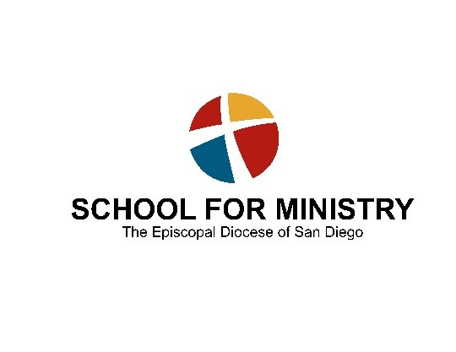

The Rev. Canon Allisyn Thomas Director of Theological Field Education

Evaluation of a Theological Field Education Experience
SUPERVISOR’S EVALUATION
Ministry site: ________________ Ministry dates: _________________
Total number on site hours worked: _____ Supervisor’s signature: ____________________
State the specific area of ministry which the postulant addressed in this experience as found in your signed learning - serving covenant:
______________________________________________________________________________
______________________________________________________________________________
______________________________________________________________________________ ______________________________________________________________________________
Rank the following by assigning a number between 1 and 5
(1 = strongly disagree, 5 = strongly agree)
- The postulant achieved his/her Learning Goals. _______
- The postulant completed his/her Ministry Work. _______
- The quality, progress and achievement in the practice of ministry area was
measured well by the postulant and by myself. _______
- Postulant received the resources needed to fulfill ministry work. _______
- The ministry of the postulant was very beneficial to those served ______
6. The degree of involvement of the Field Ed. Director was beneficial to me. _______
Observations
- In regards to the postulant’s ordination process, what do you think was the most helpful learning experience?
- Identify the postulant's growing edges and professional development needs as they have emerged out of this field education experience:
Comment upon the postulant's aptitude and readiness for ministry as they have manifested themselves in this experience of theological field education.
- Describe and assess the following:
The relationship between the student and you, the supervisor, as a resource for education and formation in ministry:
4. The way in which theological reflection was integrated into the process of supervision.

5. Describe whether and how you saw a call to ordination as deacon or priest manifested in the student’s ministry and behavior.

Please e-mail the completed form to the Director of Theological Field Education:

