EPISCOPAL VETERANS FELLOWSHIP OF SAN DIEGO

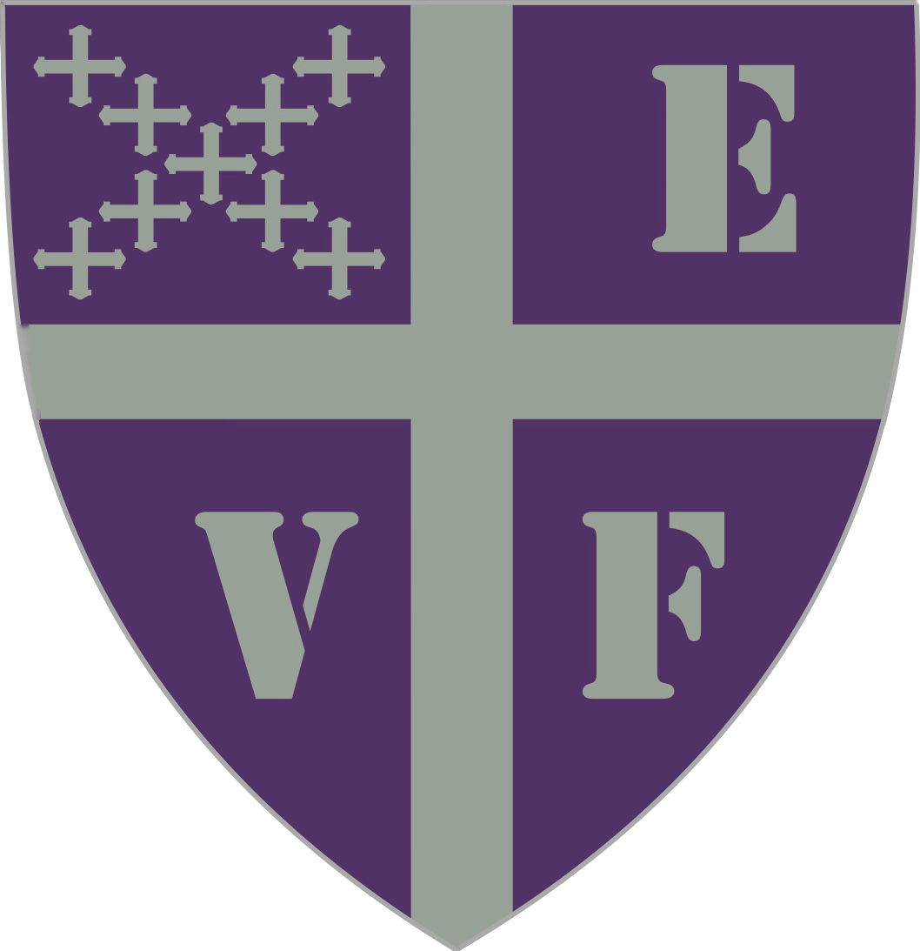
The Episcopal Veterans Fellowship (EVF) was born in 2009 in a resolution from General Convention to “Encourage the establishment of an Episcopal Veterans Fellowship for each diocese.” In 2014, with a blessing from the Rt. Rev. Andy Doyle and a grant from the Episcopal Evangelism Society, a group of veterans gathered at St. David’s, Austin, for a Pilgrimage of Remembrance and Reconciliation. It’s first members were gathered under the stained-glass window depicting St. Martin of Tours, the patron saint of veterans, they prayed for their friends who died in war and homecoming. By 2015, four parishes in the Diocese of Texas hosted EVF groups, a testament to the enthusiasm and dedication of those first members.

The Rt. Rev. Dr. Susan Brown-Snook is now establishing a Diocesan Chapter of the EVF. The EVF in San Diego will exist to equip Christians for missional ministry to veterans through prayer, hospitality, and reconciliation. We will offer educational workshops, consulting, and coaching so your church so you can reach out with God’s love to the veterans who live in your community.

The initial board of the EVF of San Diego is The Rev. Babs Meairs, Mr. Peter Martin, Mr. Michael Fitzpatrick, The Rev. Michael Tinnon and The Rev. Dr. Frank Munoz

The EVF of SD will be meeting monthly via Zoom for now. Parishes interested in establishing a chapter of the EVF should contact Fr. Munoz at fmunoz@edsd.org. In your meetings we hope to build community, learn about moral injury, lament, pray Compline, and help others with their journey home from war.
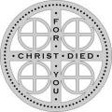

Citation: General Convention, Journal of the General Convention of The Episcopal Church, Anaheim 2009 (New York: General Convention, 2009) pp. 535-536.

