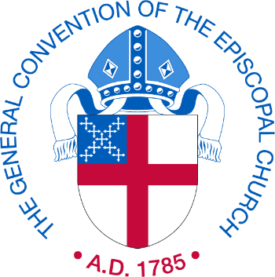

Parochial Report Filing for 2019

Dear [church name]:

Filing of the 2019 Parochial Report opens January 2, 2020.

To begin preparing for the upcoming filing year, downloadable forms and instructions are available on the Episcopal Church website at:
https://www.episcopalchurch.org/research/forms-and-instructions

New Important Information:
We have moved our online filing site to a new URL. Please save the following link:
https://reports.dfms.org

Due to site security and convenience, we are no longer providing and/or using a Unique Episcopal Identifier (UEID) and PIN as login credentials. That means beginning January 2nd, you will be asked to create a new login. In order to create a new login, you will need your UEID and PIN to begin the process. If you cannot remember your PIN, click “Forgot Password” and follow the prompts for instructions.

Note your new login will need to be an active email address and your password will be case sensitive. If you do not know your UEID, you may contact your diocesan office or look it up here: https://sites.google.com/view/episcopal-eparish-lookup/

If you are not able to file online, contact your diocesan office for help.

Please note that the canonical deadline to submit your reports to your diocese is
March 1, 2020. However, please check with your diocese for particular diocesan requirements. The final canonical deadline to the Office of the General Convention is May 1, 2020.

Reminder: Late reports are accepted but will not be reflected online. Please make sure your report is completed by the canonical deadlines. Thank you!

FACT 2020:

In addition to completing the Parochial Report, we also will be inviting you to complete a survey. This survey has been created to provide a comprehensive view of congregations in America as well as a complete understanding of the Episcopal Church life than is possible on the annual Parochial Report.

Your congregation will receive a summary of the research findings when they are complete.

We encourage you to complete the survey by June 1, 2020.

To access the survey after January 2nd, please log into the Parochial Report filing site at https://reports.dfms.org
and click the “FACT survey” tab on the left menu.

If you have questions about the Parochial Report, please email:
pr@episcopalchurch.org

