Approach Receive Find

**Nightwatch 2013**

**Participant Booklet**



**St. Peter’s Episcopal Church, Del Mar, California**

Approach Receive Find

We do not have a high priest who is unable to sympathize with our weaknesses, but we have one who in every respect has been tested as we are, yet without sin. Let us therefore **approach the throne** of grace with boldness, so that we may **receive mercy** and **find grace** to help in time of need. (Hebrews 4:15-16)

**Location of the Stations**

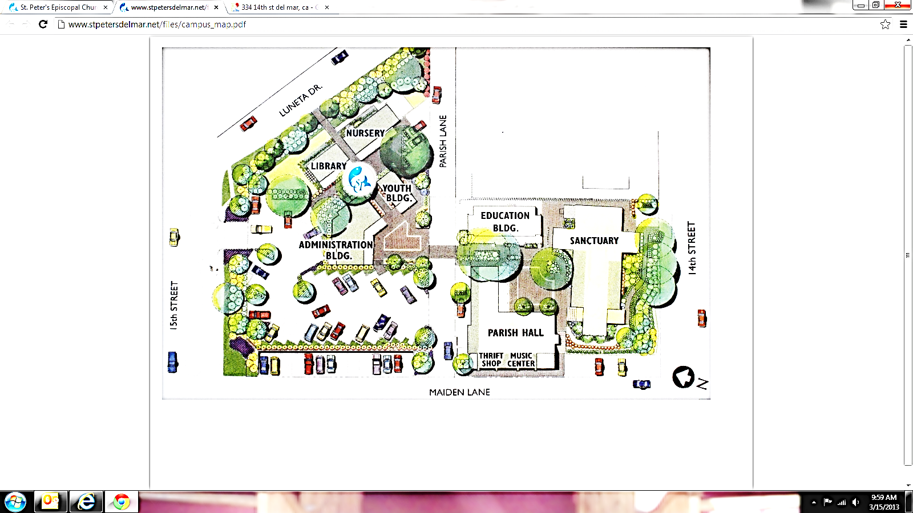

**8**

**5**

**6**

**3**

**4**

**7**

**o/c**

**1**

**2**

***Concerning the Service\****

The devotion known as “The Way of the Cross” comes from a custom widely observed by pilgrims to Jerusalem: the offering of prayers and meditations at a series of places in that city that are traditionally associated with our Lord’s passion (that is, suffering) and death.

The number of stations, which at first varied widely, finally became fixed at fourteen. Of these, eight are based directly on events recorded in the Gospels. The remaining six (numbers 3, 4, 6, 7, 9, and 13) are based on inferences from the Gospel story or from legend. If desired, these six stations may be omitted.*

The service that follows is appropriate either as a public service, or as a private practice of prayer, particularly on Fridays in Lent. It should not be done in place of the Proper Liturgy of Good Friday.

In the form that follows, the Trisagion (“Holy God”) is to be chanted as participants process from station to station. Instead, the Trisagion may be used to conclude each station, and stanzas from appropriate hymns sung as everyone moves. The hymns included in this service are offered as suggestions. It is appropriate that everyone who is present takes part in the procession.

The officiant, or leader, at the service can be either a clergy person or a lay person. The officiant customarily leads the opening verses at each station and reads the concluding Collect. The Readings (and the versicles that follow) are appropriately assigned to other persons.

*As a matter of time, we have chosen to omit the optional stations this year.

***The readings in this booklet were originally***

Adapted from *The Book of Occasional Services*

for the Church School of All Saints Parish

Brookline, Massachusetts

*©2001*

**Opening Meditation**

in the prayer garden

**What is Nightwatch? What is “The Way of the Cross”?**

Approach Receive Find

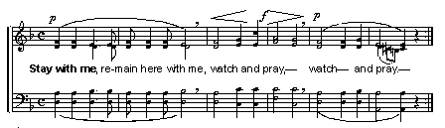**Opening Hymn:** “Stay with Me” (Taizé)

**Leader:** In the Name of the Father, and of the Son, and of the Holy Spirit. *Amen.*

Lord, have mercy.

*Christ, have mercy.*

Lord, have mercy.

**Everyone together:**

Our Father who art in heaven, hallowed be thy Name, thy kingdom come, thy will be done, on earth as it is in heaven.

Give us this day our daily bread.

And forgive us our trespasses, as we forgive those who trespass against us.

Lead us not into temptation, but deliver us from evil.

For thine is the kingdom, and the power, and the glory forever and ever. Amen.

**Group Assignments**

*Sing “Stay with Me” as you follow your group leader to your next location. Group one will go directly to the first station, while everyone else goes to the Music Room to wait.*

# First Station

on the south patio

**(1) Jesus is condemned to death**

**Leader:** Saving and forgiving God, we love you, we need you, and we trust you.

**All:** *Give us the strength to follow your way of living and loving.*

On the morning after Jesus was arrested, the Jewish and Roman leaders in Jerusalem met together and discussed what they would do to stop Jesus from preaching salvation for everyone, especially the sick and poor. They decided that he must be killed. When Jesus was brought before them, he courageously maintained his faith in God and his message of hope. Even so, they condemned him and said, “Jesus deserves to die!” Pilate, who was the Roman ruler at that time, then ordered him to be crucified.

**Leader:** Jesus faced his death.

**All:** *Because he knew God’s love was stronger than death.*

Let us pray.

Dear Jesus, for the Roman officials the cross was a sign of death. Help us as we walk the way of the cross to know that your love and courage show us what is important in life. *Amen.*

*Holy God,*

*Holy and Mighty,*

*Holy Immortal One,*

*Have mercy upon us.*

*Complete the activity on the next page, and then walk with your group to the second station. Your group may choose to sing “Stay with Me” as you walk.*

***Help Us…***

***to know what is important.***

**How much money do you spend in a day?**

Count everything, including food and transportation, whether you pay for it or someone else (like a parent) pays for it.

Use the cards to help you think of the things you buy each day and to estimate their cost.

**IF you only had $1 per day to spend, how would you spend it?**

What do your choices show about what you think is important?

Take a dollar from the table. Use the adhesive putty to stick it here to remind you

* to pray for people around the world who are poor and
* to focus on what is important.

**Second Station**

in the parish hall

**(2) Jesus takes up his cross**

**Leader:** Saving and forgiving God, we love you, we need you, and we trust you.

**All:** *Give us the strength to follow your way of living and loving.*

Carrying his own cross, Jesus began the walk to Golgotha, where he knew he would die. He did not say a word to all those who were hurting him with their words and actions. Silently, he took the weight of the cross onto himself.

**Leader:** Jesus carries the heaviness of our sins.

**All:** *He died that we might be saved.*

Let us pray.

Christ Jesus, you stood bravely while those who hated you publicly humiliated you. You quietly put up with the embarrassment of carrying the cross on which you would die. We remember your trials as we follow this path. *Amen.*

*Holy God,*

*Holy and Mighty,*

*Holy Immortal One,*

*Have mercy upon us.*

***Help Us…***

***to remember your trials as we walk this path.***

**Pick up a rock on your way into the labyrinth.**

**Take off your shoes and walk the labyrinth slowly, focusing on the weight of your rock and thinking about the burdens Jesus carried to the cross.**

*When everyone in your group has walked the labyrinth, move on to the third station. Your group may choose to sing “Stay with Me” as you walk.*

**Third Station**

in the upstairs classroom

**(5) The Cross is laid on Simon of Cyrene**

**Leader:** Saving and forgiving God, we love you, we need you, and we trust you.

**All:** *Give us the strength to follow your way of living and loving.*

A man named Simon, who had come into Jerusalem from the countryside, was pulled from the crowd to help Jesus carry the cross. Exhausted and weak, Jesus was grateful for Simon’s help. “If anyone would come after me, let him deny himself and take up his cross and follow me. Take my yoke upon you, and learn from me; for my yoke is easy, and my burden is light.”

**Leader:** Whoever follows Jesus

**All:** *Will be his disciple.*

Let us pray.

Christ Jesus, you were grateful for Simon’s help. Bless all those who reach out to us and offer help—our parents, teachers, and friends. Let us remember that acts of kindness are blessed in your sight. *Amen.*

*Holy God,*

*Holy and Mighty,*

*Holy Immortal One,*

*Have mercy upon us.*

*Complete the activity on the next page, and then walk with your group to the fourth station. Your group may choose to sing “Stay with Me” as you walk.*

***Help Us…***

***to be thankful for those who offer us help.***

Somebody prayed for me, had me on their mind, took the time and prayed for me. I’m so glad they prayed; I’m so glad they prayed; I’m so glad they prayed for me.

**Press play on the CD player to listen to “Somebody Prayed for Me”**

**The collect for this station reminds us that many people “reach out to us and offer help—our parents, teachers, and friends.”**

* Who can you think of who has offered you help?
* Write their name(s) here:

**While you are listening, make a card of thanksgiving for the person or people you named.**

Decorate the card and write that person’s name on it.

Write a short prayer of thanksgiving to God or thank you note to the person on the inside of the card.

**When the music is over, put your card in the basket. At the end of Nightwatch you can come back for the card if you’d like to keep it or give it to the person for whom you gave thanks.**

# Fourth Station

on the north patio

**(8) Jesus meets the women of Jerusalem**

**Leader:** Saving and forgiving God, we love you, we need you, and we trust you.

**All:** *Give us the strength to follow your way of living and loving.*

A large group of people who loved Jesus began to follow after him. In the crowd were women who cried with great sadness, for they knew that Jesus was suffering and that he would soon die. But Jesus turned to them and comforted them.

**Leader:** Those who watered the earth with tears

**All:** *Will bring in a large harvest with songs of joy*.

Let us pray.

Night turns to day, and sorrow into hope. Dear Lord, by your loving kindness, pardon us. *Amen.*

*Holy God,*

*Holy and Mighty,*

*Holy Immortal One,*

*Have mercy upon us.*

*Complete the activity on the next page, and then walk with your group to the fifth station. Your group may choose to sing “Stay with Me” as you walk.*

***Pardon Us…***

When our hearts are broken by the suffering of others or when we need to change direction in our own lives, Jesus will comfort us. That’s what we mean when we say that Jesus will forgive us if we repent of our sins.

Sin is a church word for all the ways we fail to live up to our full potential as God’s children. The attitudes and actions that separate us from God and from who we can be in God’s kingdom seem to keep us going in the wrong direction.

**What do you need to ask forgiveness for? What have you done that you are ashamed of? How have you disappointed yourself or failed to live up to your potential?**

**As you think about your “sin,” take a couple of sticks and bind them together with some string to make a cross.**

Write “Lord Jesus Christ, have mercy on me, a sinner.” on your cross. Hold the cross in your hands for a little while meditating on your sin and God’s forgiveness. Do this quietly, keeping company with Jesus.

C:\Users\apriltsmith\AppData\Local\Microsoft\Windows\Temporary Internet Files\Content.IE5\A9C0ZWKT\MC900347497[1].wmf

**It’s OK to make more than one cross. Just leave what you make in the basket. These crosses will be used as kindling to start the new fire of Easter on Saturday evening.**

**Fifth Station**

in the youth room

**(10) Jesus is stripped of his clothes**

**Leader:** Saving and forgiving God, we love you, we need you, and we trust you.

**All:** *Give us the strength to follow your way of living and loving.*

When they came to Golgotha, the Roman soldiers offered Jesus wine to drink that had been mixed with bitter herbs. But when he tasted it, he would not drink. And they took his clothes off him and divided what he had been wearing among them.

**Leader:** They gave me bitter herbs to eat:

**All*:*** *And when I was thirsty they gave me vinegar to drink*.

Let us pray.

Jesus, you were hurt and naked. Help us to reach out to those who suffer brutality for justice and peace. Help us to put an end to acts of vengeance and bigotry. *Amen.*

*Holy God,*

*Holy and Mighty,*

*Holy Immortal One,*

*Have mercy upon us.*

***Help Us…***

***to strive for justice***

**Use the supplies on the table to pack a lunch for a homeless person.**

While you pack the bag lunch, pray for the person who will eat this lunch and ask God to help you and St. Peter’s to work for an end to homelessness.

**If you have time, you may pack more than one lunch.**

*After about four minutes of praying and packing, walk with your group to the sixth station. Your group may choose to sing “Stay with Me” as you walk.*

# Sixth Station

in the downstairs classroom

**(11) Jesus is nailed to the cross**

**Leader:** Saving and forgiving God, we love you, we need you, and we trust you.

**All:** *Give us the strength to follow your way of living and loving.*

At Golgotha they crucified Jesus, and with him they crucified two criminals, one on the right, the other on the left, with Jesus between them. And what the prophet Isaiah had said came to pass: “He was numbered with the prisoners.” One of the criminals knew that Jesus was innocent and asked Jesus to remember him before God. To him Jesus said, “Today, you will be with me in Paradise.”

**Leader:** Many are rejected and despised.

**All:** *But Jesus is always merciful.*

Let us pray.

Lord Jesus Christ, you stretched out your arms in love so that everyone might come within the reach of your saving embrace. We want to bring your love to others for the honor of your Name. *Amen.*

*Holy God,*

*Holy and Mighty,*

*Holy Immortal One,*

*Have mercy upon us.*

*Complete the activity on the next page, and then walk with your group to the seventh station. Your group may choose to sing “Stay with Me” as you walk.*

***Help Us…***

***to remember your sacrifice and your love.***

Just like the criminal beside Jesus, we can pray in Jesus’ name and be answered. Sometimes it is hard to remember that we can trust God, but if we remember that Jesus was loving and forgiving even as he died, trusting in God’s love is easier.

**Pick up a rock. Turn it over in your hand a few times, noticing its texture, weight, and color.**

If you don’t feel a connection to this rock, try again.

**When you have found a rock you like, use a paint pen to write a word that reminds you of Jesus’ love on the rock.**



**Pick one of the following meditations and say it three times while turning the rock over in your hand.**

When I am afraid, I put my trust in you. Lord help me

*Psalm 56:3* to remember

that nothing

Take my side, God—I’m getting kicked around. is going to happen

*Psalm 56:1* to me today

that you and I together

Yes, indeed—God is my salvation. can’t handle. *Amen.*

I trust, I won’t be afraid.

God—yes God!—is my strength and song, Grant us grace, almighty Father,

best of all, my salvation! so to pray as to deserve to be heard.

*Isaiah 12:2* Hear now our silent prayers, O God.

**Put your prayer rock into your pocket or use the straps, glue, and wire to make a bracelet to help you remember to trust God’s forgiving love.**

**Seventh Station**

on the south patio

**(12) Jesus dies on the cross**

**Leader:** Saving and forgiving God, we love you, we need you, and we trust you.

**All:** *Give us the strength to follow your way of living and loving.*

As Jesus hung on the cross, he saw his mother and the disciple whom he loved standing nearby. He said to his mother, “Woman, here is your son!” Then he said to the disciple, “Here is your mother!” And when Jesus had received some vinegar, he said, “It is finished.” And then, crying with a loud voice, he said, “Father, into your hands I give my spirit.” And he bowed his head and died.

**Leader:** Jesus was faithful even to his death.

**All:** *Even death on a cross.*

*(Silence)*

Let us pray.

Christ Jesus, when you died on the cross, everyone thought that was the end for you. But you believed your life was in God’s care and knew great things were at hand. Help us to look for new beginnings in our lives every day, even on those days that seem hopeless. *Amen.*

*Holy God,*

*Holy and Mighty,*

*Holy Immortal One,*

*Have mercy upon us.*

*Complete the activity on the next page, and then walk with your group to the eighth station. Your group may choose to sing “Stay with Me” as you walk.*

***Help Us…***

***to look for new beginnings, even when we feel hopeless.***

**The Sand Dollar Legend**

**Upon this odd-shaped seashell a legend grand is told,**  
**about the life of Jesus, that wondrous tale of old.**  
**At its center you will see, there seems to be a star,**  
**like the one that led the shepherds and** **wise men** **from afar.**  
**Around its surface are the marks of nails and thorns and spear,**  
**suffered by Christ upon the cross; the wounds show plainly here.**  
**But there is also an Easter lily, clear for us to see,**  
**the symbol of Christ's resurrection for all eternity.**

**Take a sand dollar and hold it in your hand.**

Notice the symbols of Christianity on the sand dollar:

* the poinsettia
* the Easter lily
* the Christmas star
* the five wounds of Jesus’ passion

**Take turns using the hammer to smash your sand dollars.**

Look at the rubble of your destroyed sand dollar. Can you put it back together? Will it ever be the same?

**Now sift through the broken pieces to find the doves hidden in the debris.**

**Use some sand and your doves to make a necklace that will remind you that even in the most hopeless seeming situation, we can find something new.**

**Eighth Station**

at the memorial fountain

**(14) Jesus’ body is laid in the tomb**

**Leader:** Saving and forgiving God, we love you, we need you, and we trust you.

**All:** *Give us the strength to follow your way of living and loving.*

When it was evening, a rich man named Joseph, who was a disciple of Jesus, went to Pilate and asked for the body of Jesus. Then Pilate ordered it to be given to him. And Joseph took the body, and wrapped it in a clean linen cloth, and laid it in a cave that had been carved out of a rocky area. And Joseph rolled a great stone at the opening of the tomb.

**Leader:** Jesus will never leave us.

**All*:*** *He lives in us forever.*

Let us pray.

Christ Jesus, your body was laid in a tomb in a garden, and rested on the Sabbath day: Grant that we who love you may find perfect peace with you. *Amen.*

*Holy God,*

*Holy and Mighty,*

*Holy Immortal One,*

*Have mercy upon us.*

*Complete the activity on the next page.*

***Help Us…***

***to find peace.***

**Think of someone you know who has died.**

Say their name out loud as you light a candle. If you cannot think of anyone, you may say Jesus’ name.

Think of a special memory of that person.

**When you are ready, put your candle in the fountain and walk quietly into the church to hold vigil.**

**Your group will hold vigil at the altar of repose with the Daughters of the King for about five minutes.**

Don’t worry about time. Your group leader will let you know when it is time to go.

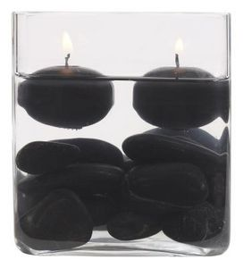

*.Follow your group leader to the Music Room to wait while all the other groups finish the stations.*

**Concluding Prayers**

in the prayer garden

*When all of the groups have gathered in the Music Room, walk together to the prayer garden, humming “Stay with Me.”*

**Leader**: Saving and forgiving God, we love you, we need you, and we trust you.

**All:** *Give us the strength to follow your way of living and loving.*

Let us pray.

We thank you, God, that by following this path you have shown us the meaning of your suffering and death. To Christ our Lord who loves us, and has made us all ministers to serve in his name, be glory for ever and ever. *Amen.*

## Closing Hymn: “I Want Jesus to Walk with Me”

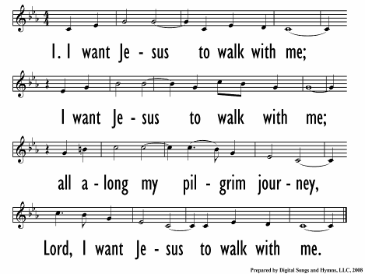

All watch silently as the cross is draped in black to symbolize our mourning. Please return to the Music Room without speaking.

Approach Receive Find

**Nightwatch 2013**

Maundy Thursday, March 28 –

Good Friday, March 29

**Schedule**

6:15pm Pizza dinner Parish Hall

7:00pm Maundy Thursday service with foot washing Church

8:30pm Gathering Prayer Garden

8:35pm Opening Meditation Prayer Garden

8:45pm Group 1 (day campers) begins the stations Patio

*Overnighters will return to the Music Room and start at 5 minute intervals.*

9:45pm Group 1 finishes the stations Music Room

*Parents of day campers can pick them up in the Music Room.*

10:00pm All groups finish, Concluding Prayers Prayer Garden

10:05pm PJs Patio Bathrooms

10:20pm Compline TBD

10:30pm Bedtime Various Locations

6:45am Wake up call

7:00am Breakfast and hang out time Youth Room

8:00am Parents arrive

*Parents of overnighters can pick them up in the Youth Room.*

**More Holy Week Services…**

Good Friday, March 29

Good Friday Liturgy with Veneration of the Cross – noon, 7pm

The Stations of the Cross – 1pm

The Great Vigil of Easter

Saturday, March 30 – 7:08pm

Easter Day, March 31

7:30am, 9am, 11am