Military Ministry

Tool Kit

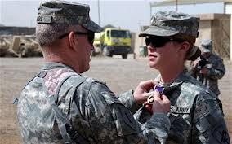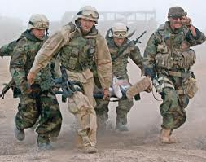

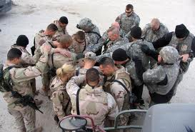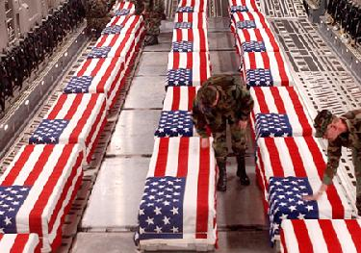

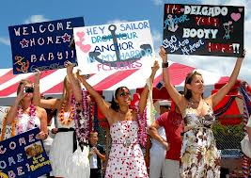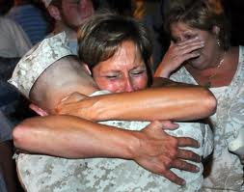

Presented by the Evangelism Committee of the Episcopal Diocese of San Diego

Some material excerpted from
The Guidebook For Leaders for Military Ministry Congregational Programs
Developed by CareForTheTroops, Inc.
WHAT IS THIS ABOUT?

It is a fact that many active duty and veterans of the Middle East and other wars return with combat stress syndromes that have the potential to impair them for life. War is a blatant source of evil because it forces combatants to normalize abnormal behavior to survive its ravages. For a combat veteran, “War is hell” is a statement of fact. For the returning service person, the inability to reconcile his or her battlefield actions with the spiritual, religious, moral and ethical beliefs deeply ingrained in them during their upbringing deeply wounds the soul and causes loss of self. The terrible consequences of these types of wounds mirror those suffered in past conflicts – depression, homelessness, suicide, and lifelong alienation from God, self, and others. Adjunct to this are the outcomes of the adoption of self-medicating practices (i.e. alcohol, drugs, other addictions, thrill seeking activities) that exacerbate rather than alleviate the pain and suffering.

The Episcopal Diocese of San Diego recognizes that an outreach opportunity exist at its doorstep that is unique. Within diocese boundaries there exist twenty (20) United States Military Installations (sixteen (16) are in San Diego County) that are the nucleus of a mission field that contains the single largest concentration of active duty and U.S. Armed Forces veterans in the nation. In recognition of this and in faithful obedience to baptismal covenant vows and the great commandment, the diocese intends to increase our outreach efforts in the military mission field. This toolkit seeks to assist in achieving this goal in three ways.

First, it serves to inform interested parties about this exciting and highly diverse mission field. The hope is that information can be the impetus to increasing outreach activity in the field.

Secondly, the toolkit provides the means for easy entry into the military mission field. This is accomplished using valid congregational ministry programs and web related resources that address a variety of service member and/or veteran needs.

Third, the toolkit serves to broaden the resources available to those who are already serving in the military mission field or to act as a catalyst for the start of a new ministry.

The following paragraphs provides additional mission field information to include the guidance and resources needed to easily start a ministry in this mission field.

HOW BIG AND WIDE IS THE NEED?

The local military mission field is composed of active duty personnel, veterans to include retirees, and their spouses and dependents. Based on the most current data available, there are approximately 156,000 active duty military personnel currently serving within the San Diego County area. The addition of dependents and families results in a total estimated active duty military population of around 365,000. Due to the dynamics caused by the high operational tempo over the past 10 years, the actual size of the active duty population is in constant flux but its scale remains noteworthy. As an example, reducing the estimated total population figure by 15% results in a figure that exceeds the populations of 17 of the 18 largest incorporated cities in San Diego County (2010 Census data used).

San Diego County has an estimated 260,000 veterans living within its boundaries, making this area the largest concentration of veterans in the nation. Drawn to the area for its weather, second career opportunities, and easy access to a large number of Veterans Affairs (VA) and military-run healthcare and shopping facilities, the veteran component includes a large number of military retirees and their spouses. Due to major advances in Medical Science in concert with improvements in casualty treatment procedures, survival rates for the seriously wounded (physical and mental) are at an all time high. For this reason, the veteran component also includes a growing number of severely disabled individuals who require long-term rehabilitation and care. Included in this group are individuals under treatment for Post Traumatic Stress Disorder (PTSD), Traumatic Brain Injury (TBI), and, most importantly, wounds of the soul previously discussed. Another facet are the dynamics brought on by the generational differences of WII Veterans, Korean and Vietnam War veterans, and veterans of the Gulf War and our on-going efforts in Iraq and Afghanistan. The worldviews of each of these veteran groups are quite different. Beyond generational differences, many of our newest veterans are women who are suffering from the same combat deployment induced stresses, strains, and ills being suffered by their brothers in arms. The needs of this mission field is becoming gender non-specific in many areas with each passing day.

For the Diocese of San Diego, the magnitude of 600,000 + person community to be served grows even larger with the inclusion of the active duty and veteran communities associated with the Marine Corps Air Ground Combat Center, Twenty-Nine Palms; Naval Air Facility, El Centro; U.S. Army Proving Grounds, Yuma; and the Marine Corps Air Station, Yuma. Each of these installations is within the Diocese of San Diego but outside San Diego County.

As briefly described the large numbers of men and women who comprise the local active duty and veteran communities provide a mission field that is growing, dynamic, in constant flux, and ripe with challenge. The need is great and a call to serve in any capacity should be prayerfully considered.

WHY THE CHURCH

The Church is most suited to help this nation’s warriors and their families heal from the physical, spiritual, moral, and psychological wounds that every war brings. As Christians, we understand evil, hell, suffering, and, most importantly, the power of Christ’s redeeming love to overcome deep seated feelings of fear, guilt, and shame. We are in the business of reconciliation and are especially expert in creating the loving, understanding, and safe environment needed to start wounded souls on the road to recovery. The urgent need is not to be an expert in psychology or physiology, but rather a caring and loving ambassador of Christ who is a servant to those who have suffered debilitating wounds during their service to the nation. The question then is “are you being called to be the hands of the Good Shepherd in the military mission field, to return the lost to the flock, to be the light of Christ that helps show returned warriors the true way home?”

HOW DO I GET STARTED?

Getting started is easy. Review the following military ministry program templates and resources and select the program or resource that appeals to you. Ministry programs are presented in Parts 1 and 2, web-related ministry and referral resources are contained in Part 3 of this toolkit. Additionally, Parts 4 and 5 are included as guidance for those parishes wishing to be designated as a Veteran Friendly Congregation (VCF) and/or a Lead Congregation (LC) within their community. Both of these designations are part of overall Congregation-based Military Ministry Program effort designed and administered by CareForTheTroops, Inc.
To aid in the selection process, a quick reference page containing hyperlinks is included. This provides quick lookup of the program, resource, and guidance sections of the toolkit. It is as easy as selecting a military program template or resource, reading the provided program guidance or resource contact information on how to get involved, and going to work.

Lastly, being an ambassador for Christ in the mission field means conscientiously choosing to act and talk in a manner that brings glory to him and grows his kingdom. This must be done in a manner that is respectful of those you are serving, but promoting Christ in the world must be the primary objective.

PRAYERS FOR MISSION AND OUR ARMED FORCES

Everliving God, whose will it is that all should come to you through your Son Jesus Christ: Inspire our witness to him, that all may know the power of his forgiveness and the hope of his resurrection; who live and reigns with you and the Holy Spirit, one God, now and forever. Amen.

BCP Page 816

Almighty God, we commend to your gracious care and keeping all the men and women of our armed forces at home and abroad. Defend them day by day with your heavenly grace; strengthen them in their trials and temptations; give them courage to face the perils which beset them; and grant them a sense of your abiding presence whenever they may be; through Jesus Christ our Lord. Amen.

BCP Page 823

Table of Contents

Directions: Place cursor on desired subject matter and follow pop-up directions. To return to this page, place the cursor on the closest hyper-linked heading and follow the pop-up directions.

Toolkit Presentation Page

Part 1 – Congregation Program Templates 6

Program 1: Prayer List Identification - Spiritual Support and Care 7
Day of Worship Bulletin and/or Newsletter Article – Example 8
Prayer List Example 9
Military Deployed List Example 10
Returned Home List Example 11
Military Prayer List Example 12
Program 2: Dedicating An Existing Program To Honor Service Members 14
Program 3: Care Packages to Deployed Service Members 15
Care Package Leaflet Example 18
Program 4: Operation International Children – School Supplies Kits 20
Program 5: Assistance and Practical Help to Congregation Members 22
Program 6: Assistance and Practical Help Outside the Parish 23
Program 7: Recognition of Congregation Veterans 24
Program 8: Books for Soldiers 25
Program 9: Workshops Conducted by The ArtReach Foundation, Inc.® 27
Program 10: Writing Our Way Home 29

Part 2 – Other Congregation Programs 35

Part 3 – Selected Web Site Resources for Ministry or Referrals 37

Part 4 – Veteran Friendly Congregation (VFC) Designation - Implementation Guide 42

Veteran Friendly Congregation (VFC) Approval/Renewal Letter Example 47
Letter from Congregation Leadership to Congregation, Example 1 48 Letter from Congregation Leadership to Congregation, Example 2 49
Letter to a Congregation Member in the Military or Relative Example 50
Article in Congregation Newsletter or Email to the Congregation Example 51

Part 5 - VFC and Lead Congregation - Designation Program 53
VFC Approval / Annual Renewal Letter Example 54

LC and VFC Responsibilities Comparison Table 56
Part 1 – Congregation Program Templates

INTRODUCTION

This section contains the templates of programs you can implement as part of the overall Military Ministry Program in your congregation. You may include as many of the programs as you want in your ministry effort in addition to those you are already doing or are planning to do. We request that you consider implementing at least two programs. This will provide sufficient opportunity to “advertise” the fact that the church leadership has made a commitment towards the establishment of a Military Ministry effort. This advertising also serves to promote support and participation within the congregation for this ministry effort.

It may be repetitive, but it is an important point to repeat: Each congregation can customize the Military Ministry to fit the profile of their location and members. It is not even necessary to call it a Ministry. What is important is that there is activity that visibly supports military members and their families.

The templates are listed in increasing order of difficulty and effort.

One very important task is creating a complete list of the military members, past and present, who have served, including name, rank, branch of service, address, names of family members, and relationship to the congregation. This list will be useful when implementing selected template programs. More importantly, it allows for identification of active duty and veterans who are members of congregation and may be interested in supporting this ministry.

Program 1: Prayer List Identification - Spiritual Support and Care

GOAL: Highlight in the congregation’s Prayer List those who are deployed and/or those who have returned. This will help build in the congregation an awareness of military member needs as well as demonstrate to selected service members that their church cares and intends to provide them spiritual support while they are away.

COORDINATOR(S): (names, phone numbers, emails of those responsible for the program)

ESTIMATED ANNUAL BUDGET: $0 to $50 - Some costs might occur if you decide to send letters or to display the prayer list in a manner that enables viewing by visitors and members of the congregation.

EXECUTION STEPS:

- One of the most important things the congregation can do for the troops is to pray for them each day. If you have a service bulletin or include special prayers during the worship day services, please include a section that lists members of the congregation or their family who are serving overseas.

- An example listing in the Day of Worship bulletin is provided at the end of this section, and would be used in the reading of the names of those who would be included in the prayers during the service. This affirms the congregation’s compassion for the troops and their interest in supporting and sustaining any military personnel and their families who might attend or visit the congregation.

- Use the prayer list to help track names and pertinent information of those deployed and also those that have returned. Examples of these lists are at the end of this section.

- In addition, if the congregation has a regular group that offers weekly and daily prayers for the needs and support of others, include these lists for their use.

- Consider sending a note or email to the military personnel indicating that they are on the prayer list until they return to U.S. soil.

- Include an announcement in the weekly or monthly bulletin. An example follows this section.
Day of Worship Bulletin/Newsletter Article - Example

PASTORAL CARE NEWS -
Military Personnel Prayer Ministry
Our congregation prayer ministry is expanding to include our military personnel in harm’s way. If you have listed someone on the prayer list who is currently serving in our military in harm's way, please email or phone the congregation office with the name and military address of the person. We will send that person a special card created by (name of person). Additionally, that person will be listed in a section of the prayer list devoted to those associated with the military.

Additional bulletin content may include:
- …a description of the card that will be sent
- …what the words and the prayer that will be put on the card
- …who will be responsible for sending the cards in case someone wishes to contact them
- …the name and number at the congregation office who should receive the information

We suggest running this announcement once a month.
Prayer List Example

[NOTE: The key point of showing this is that the military is singled out as a separate group thereby increasing awareness in the congregation of their existence and distinct issues.
(Highlighting is omitted)

Daughters of the King pray daily for those listed below as part of their commitment to service & prayer.

Members of our Parish Family

[name]  [name] | [name] Family  [name] | [name]  [name] | [name]s  [name]

For Those Who Have Died
† [name], friend of [name]

For our Military Personnel

[name], [name], [name], [name], [name], [name], [name], [name], [name], [name], [name] [name], [name], [name], [name], [name], [name], [name],
[name], [name]., [name], [name], [name], [name], [name], [name]

Expectant Parents of our Parish Family

[name]~ due (month) 20__
[name]~ due (month) 20__

[name]~ due (month) 20__
[name]~ due (month) 20__

Family Members of our Parish Family

[name]  [name] | [name]  [name] | [name]  [name] | [name]  [name].

Friends of our Parish Family

[name]  [name] | [name]  [name] | [name]  [name] | [name]  [name]
Long Term Prayer Concerns

[name], [name], [name], [name], [name], [name], [name], [name], [name], [name], [name], [name], [name], [name], [name] [name], [name]

Military Deployed List Example

Military Deployed in Harm’s Way

- [name] has been deployed to the Middle East. He is my cousin and nephew to [name]. [name] and [name] ([name]’s cousin)

- [name]– Afghanistan through July/August 20__ – Brother of [name]

- [name]– Army – friend of [name] – stationed in Germany – deployed to Iraq March 10.

- [name]– son of [name] – security

- [name]–

- [name]– cousin of [name] – phone # – Deployed to Iraq – 4.28.11 – Ranger Battalion

- [name] – friend of [name] – phone # – October ‘12

- [name]– Son of parishioner [name]– marine – deployed to Iraq – October 20__ – phone #

- [name] – deployed to Iraq – October 20__ – [name] (no relation given)

- [name] – deployed to Iraq – submitted by [name] family – phone #

- [name], son of [name]– being deployed to Iraq/Afghanistan after Christmas holidays – 12.16.12

- [name], friend of [name]– 1.27.13

- [name]., husband of colleague – [name]– phone # – just deployed to Iraq – March 2012

- [name], cousin of [name] – deployed to Iraq – April 2012

Returned Home List Example

Military Who Have Returned Home

- [name]– Home 6/5/12 – [name]brother

- [name]– [name]– returned home from Iraq 6/15/12 but may have to return.

- [name] shipped to Iraq – Nephew of [name] – returned home from Iraq 7/8/12

- [name]– son of [name] – deployed 2/25/11. Advised by [name] to transfer him to prayers for healing on August 29, 2012.

- [name]– 4.26.11 – deployed to Iraq – Message was left on receptionist phone – [name]12.28.12 (got home on 1.3.13)

- [name]– deployed to Afghanistan – October 12, 2008 – returned 1/29/09 - dear friend of [name] (and [name]) [name] – phone # – will redeploy to Afghanistan in (month)

7. [name]– deployed to Iraq for 7 months October 2011 – nephew of [name] (parishioner) – phone #
Returned home October 2012
MSgt [name]
Unit name
FPO AP xxxxx-xxxx

8. [name], contact [name]. Home from Afghanistan 4/09.

9. [name]– returned from Iraq 5/09 – [name]

Military Prayer List Example

Military Prayer list – 2013

_________________ Church

Thank you for continuing to pray for our military and their families

Deployment | Name | Peachtree Connection
AFGHANISTAN Home | LTC [name], US Army | Parents - [name]
AFGHANISTAN Home | 1LT [name], US Army | Grandparents – [name]
 | MAJ [name], US Army | Aunt & Uncle - [name]
 | LtCol [name], US Air Force | Sister - [name]
 | Sgt [name], US Marine Corps | Parents - [name]
 | SSG [name], US Army | Parents - [name]
DEPLOYED-Home | Maj [name], US Marine Corps | Member of Peachtree
 | Cadet Corporal [name]  West Point Military Academy | Parents – [name]  Sister - [name]
LONDON | Petty Officer 1ST Class [name], Naval Reserve | Brother - [name]  Uncle to [name]
IRAQ | CPT [name], US Army | Aunt - [name]
IRAQ | SGT [name], US Army | “
 | SGT [name], US Army | “
TOAFGHANISTAN/09 | SGT [name], US Army | “
 | CPT [name], US Army | “
DEPLOYED | PFC [name], US Army | PPC member  Grandparents – [name]
TO IRAQ 9/09 | SGT [name], US Army | Aunt & Uncle - [name]
KUWAIT | LT [name], US Navy | Grandparents – [name]
TO MID EAST 6/09 | LCDR [name], US Navy | Parents - [name]
 | SGT [name], US Army | Grandparents [name]
 | 1LT [name], US Army | Aunt/Uncle – [name]
IRAQ-Home | CPT [name], US Army | Parents - [name]
AFGHANISTAN-Home | CPT [name], US Army | “
Doctor at Walter Reed | LTC [name], US Army | Parents - [name]
 |  | “
 | MAJ [name], US Army | “
TO AFGHANISTAN | Capt [name], US Marine Corps | Parents – [name]
 | ENS [name], Navy Seal Training | Parents – [name]
IRAQ | SPC [name], US Army | Parent - [name]
IRAQ - Home | Capt [name], US Marine Corps | “
 | AB [name], US Air Force | Parent - [name]
IRAQ – Home | PFC [name]- US Army Medic | Grandparent – [name]
MIDDLE EAST SPECIAL FORCES | Capt [name]- US Air Force | Wife - [name]  Children – [name]
AIR FORCE TWO | Capt [name], US Air Force pilot | Nephew - [name]
TO KOREA 7/09 | Capt [name], US Air Force | Grandparents - [name]
 | PV2 [name], US Army | Grandparents - [name]
 | SFC [name], US Army | Parents-in-law – [name]
 | SGT [name]., US Army Reserve | Parents - [name]& [name]
DEPLOYED | PO3 [name] | Aunt/Uncle – [name]
 | Lt [name] | “ “
GERMANY | 1LT [name], US Army | Aunt & Uncle - [name] & [name] [name]  Cousins – [name]& [name] & [name]
 | MAJ [name], Reserve surgeon | Aunt – [name]

DECEASED

LtCol [name], Marine Aunt – [name]
12/02/12 Cousin – [name]
Mother – [name]

Contact: Please call for any changes or updates. [Name] xxx-xxx-xxxx
Program 2: Dedicating an Existing Program to Honor Service Members

GOAL: By dedicating an existing meeting event and advertising the dedication to the congregation, the following objectives are achieved:

- The congregation is made aware of the service of our Armed Forces to the nation.

- Fosters a sense of acceptance for those in the congregation who are active duty members or have family members who are on active duty

- Promotes a sense of belonging to those service members and their families who are considering joining the congregation.

COORDINATOR(S): [names, phone numbers, emails of those responsible for the program]

ESTIMATED ANNUAL BUDGET: $0 (as this is meant to merely ‘piggyback’ on an already existing funded event.)

EXECUTION STEPS:

- Look for existing programs that are already funded but not specifically dedicated to support specific congregational ministries. This effort is not meant to displace any existing programs.

- A couple of examples might be coffee time before and after church services, or a week-day evening pot-luck dinner that is held to promote fellowship in the congregation or to help support week-day education programs.

- The idea is to designate one of those weekly sessions “in honor of those serving our county” or “those in our congregation who are currently deployed” or some other dedication that recognizes the service of those in the military.

- If the program chosen is one that allows for education, presentations, or interaction among the participants, ….AND…. if there are enough military family members and veterans in the congregation, you may hold an evening program that is specifically tailored to their needs and interest.

- It is very important to advertise the chosen programs or sessions in the service bulletin or in the newsletter to promote the three program goals previously discussed.
Program 3: Care Packages to Deployed Service Members

GOAL: Collect and ship items suitable for use by those serving in Iraq or Afghanistan. Helping the deployed military member know that the people back home have their needs in mind as well as help those in the congregation to feel connected to the military members serving overseas.

COORDINATOR(S): [names, phone numbers, emails of those responsible for the program]

ESTIMATED ANNUAL BUDGET: $200 to $500 (depends on how large a display and how many displays used around the facilities; also depends on postage from how many packages and how often sent)

EXECUTION STEPS:

- Identify a visible location in the Church where a large well-marked collection box or container (2ft by 2ft or larger) can be placed.
- Wrap or decorate the container with bright colors (red, white, and blue are suggested), or a Stars and Stripes covering, to draw attention to the collection point for the items. Additionally, make a poster advertising the collection and post it near the box.
- Create a leaflet or brochure describing the items that are best suited for sending, as well as the donation destination or unit for which the collection is being made. See example at the end of this section.
- The best choice for the destination unit is one that is associated with one of the congregation members. If appropriate, a small write up and picture could be included in the bulletin provided on the day of worship and also on the poster near the collection box. If you do not have a unit associated with a congregation member, or relative, three options are:
  - Choose a unit with someone assigned to it from the local community.
  - Contact the nearest National Guard Armory or Reserve unit and ask their assistance in locating a deployed service member from your community.
  - Contact www.operationhomefront.net/california/ them to suggest a deployed unit from within the state, preferably one that is nearest your location.
- At least once every two months provide an update to the congregation from the unit receiving the articles. The updates can appear near the collection box, in the bulletin published on the day of worship, newsletters, and/or in an area frequented by the congregation members.
- The box should be checked frequently so as not to let it overflow. Once sufficient quantities are collected, they should be packaged and dispatched to the identified unit. There is a mailing cost associated with this step that should be acknowledged before beginning this program.
- By working with a local Guard or Reserve unit, they may ship the package at no cost.

The suggested list of items to be packaged and sent to service members in Afghanistan or Iraq includes:
- Black or Green Wool Socks
- Pre-aid telephone cards
- Blank Computer CD’s
- Stationary Items, e.g. envelopes, paper (Pens not needed as they are already issued)
- Stamps
- Moist (Baby) Wipes
- Toothbrushes
- Crest Pro-Health Toothpaste – best for use in non-fluoride environments
- Dental floss
- Listerine Purple Mouthwash with fluoride
- Deodorant
- Shave cream
- Hand cream
- Q-Tips
- Feminine hygiene items
- Acne face wash
- AA battery=powered electric razors – no disposable razors
- Sunscreen/aftershave hybrid lotions
- Eye drops/nasal saline
- Vitamins
- Crystal Lite – individual packets
- Shoe Inserts (Gel or other durable types as low-end foam will not last)
- DVD Movies (comedy or action)
- Hard Candy
- Paperback Books/General Interest Magazines
- Smokeless Tobacco in Plastic Tins (Top Sellers are Copenhagen Snuff; Copenhagen Long Cut, Skoal Mint; Kodiak Mint/Evergreen; Marlboro Fine Cut (best value as 50% of other items); Red Man pouches; Levi Garrett pouches
- Gum
- MP3s that are all one Genre (New Country; Top20/Pop; Rap; R&B

Some final suggestions:
- The following web site provides a tremendous amount of valuable information regarding sending care packages. We consider www.operationmilitarypride.org/ the “Cadillac” website on this topic.
- The size of the box should err of the side of LARGE; we suggest at least a 24” cube. The boxes are easily available at Lowe’s, Home Depot, Wal-Mart, and other big-box stores.
- The box should have the leaflets mentioned earlier placed in a “pocket” attached to the box so that people interested in supporting this program can take it home and use it as an easy reminder of what the items they can bring back and deposit in the box.
- A poster, like those used in many school projects and easily found in a supermarket, should accompany the box placement.
- The poster should briefly describe the program’s purpose, include the list of items, the name of the unit that will get the items, and a picture and short description of the individual(s) connected to the congregation that will receive the items.

SUNDAY ANNOUNCEMENT: A Day of Worship bulletin announcement should be included that point out the existence of the box, its purpose and meaning. Run the announcement at least once a month.

NEWSLETTER ARTICLE: If the congregation has a newsletter, include a short article announcing the program, its purpose, and info on the unit that will receive the goods. We suggest running the article each year around Memorial Day, 4th of July, and Veterans Day.
Care Package Leaflet Example

Please take one:

Collection of items to send to military units serving in Iraq or Afghanistan

PURPOSE: Support those deployed in the same unit as [name of service member in the congregation if known] who is the (describe their relationship with a member of the congregation) i.e. son of John and Mary Smith)

The following list of suggested items will be packaged and sent to service members in Afghanistan or Iraq. Periodic updates from the units will be given in the [locally used named] newsletter:

- Black or Green Wool Socks
- Pre-aid telephone cards
- Blank Computer CD’s
- Stationary Items, e.g. envelopes, paper (Pens not needed as they are already issued)
- Stamps
- Moist (Baby) Wipes
- Toothbrushes
- Crest Pro-Health Toothpaste – best for use in non-fluoride environments
- Dental floss
- Listerine Purple Mouthwash with fluoride
- Deodorant
- Shave cream
- Hand cream
- Q-Tips
- Feminine hygiene items
- Acne face wash
- AA battery=powered electric razors – no disposable razors
- Sunscreen/aftershave hybrid lotions
- Eye drops/nasal saline
- Vitamins
- Crystal Lite – individual packets
- Shoe Inserts (Gel or other durable types as low-end foam will not last)
- DVD Movies (comedy or action)
- Hard Candy
- Paperback Books/General Interest Magazines
- Smokeless Tobacco in Plastic Tins (Top Sellers are Copenhagen Snuff; Copenhagen Long Cut, Skoal Mint; Kodiak Mint/Evergreen; Marlboro Fine Cut (best value as 50% of other items); Red Man pouches; Levi Garrett pouches
- Gum
- MP3s that are all one Genre (New Country; Top20/Pop; Rap; R&B

If you know of anyone who is serving from the congregation, or related to someone from the congregation, or from the local community, please make this known to [name of program leader, phone #, or email@xxx.com] so we can identify the appropriate contacts to receive the packages.

Finally the most important thing we can do for the troops is pray for them each day.

Newspaper Article Where the Care Package Idea Originated

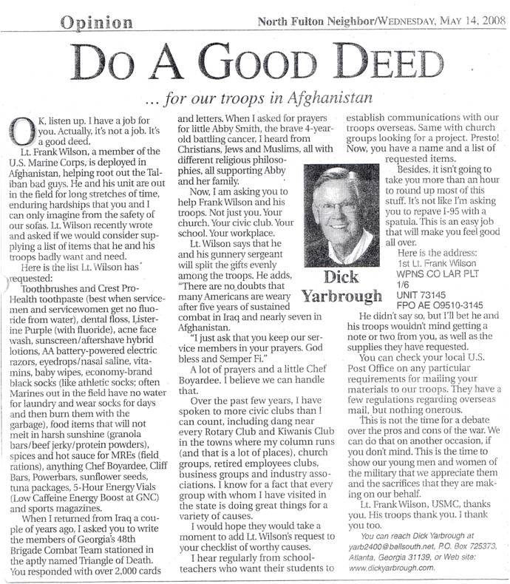
Program 4: Operation International Children – School Supplies Kits

GOAL: To help our soldiers help the children of Iraq, Afghanistan, and other parts of the world by supplying the soldiers with simple school supplies kits or pens, which they can give to the children of war torn countries they are serving in. This will promote goodwill between our service members and the citizens of these countries and help in their mutual efforts to heal the wounds of war.

COORDINATOR(S): [names, phone numbers, emails of those responsible for the program]

ESTIMATED ANNUAL BUDGET: $200 to $500 (depends on how large a display and how many displays used around the facilities; also depends on postage from how many packages and how often sent)

EXECUTION STEPS:

1) Identify a visible location in the Church for a well-marked collection box or container.
    - Wrap or decorate the container with bright colors or pictures of children and school supplies and well as red, white, blue colors, to draw attention to the collection point for the items.
    - Make a poster advertising the collection and post it near the box.
2) Create a leaflet or brochure describing the school supplies that are needed, as well as the information on Operation International Children.
3) Print the Donor Information Sheet provided at http://operationinternationalchildren.com complete and send it with each shipment. If you want to include pictures of, or stories about your group’s effort, please do! You can also send the information to OIC at oicinfo@ptpi.org
4) Assemble each kit in a backpack or zipper seal bag. Please enclose no additional items.
    - Use sturdy boxes. Banana boxes work well, but a piece of cardboard or a paper grocery bag must be taped over the hole in the top and bottom of the box before shipping.
    - Along with your donations, you may enclose a letter or set of letters from you, or your organization (e.g. your congregation’s Military Ministry) to the soldiers who will deliver your packages or to the Iraqi/Afghan children who will receive them. You may include photos, of your group assembling packages, and suggest that the soldiers or children send back their own pictures and letters.
- Do not include any full names or addresses on the letters or pictures.
If you have requested a response from the soldiers or Iraqi children, enclose a self-addressed, stamped envelope. Recipients of OIC supplies have been instructed to send replies to donors directly to the OIC Warehouse. OIC will forward these responses using the provided envelope.
- Please do not enclose religious or political materials.
- Be sure that all boxes are securely taped. In clear, bold writing, address each package to:
Operation International Children
1529 Atlantic
North Kansas City, MO 64116
USA
Go to the Operation International Children’s website for more information and suggestions http://operationinternationalchildren.com

List of items is to be packaged and sent to Operation International Children

Option 1: OIC SCHOOL SUPPLIES KIT:

- One pair of blunt-end scissors
- One 12-inch ruler with metric markings
- 12 new pencils with erasers
- One small pencil sharpener
- One large eraser
- One box of colored pencils (Crayons melt in the summer heat!)
- One package of notebook paper
- One composition book
- Three folders with inside pockets
10 One zippered pencil bag
Option 2: PENS
Pens are an important item valued by people, especially children, in Afghanistan and Iraq. Collect the pens and follow the directions above if you wish to use the OIC facilities or use a direct connection to a unit if you already have one. The packaging directions still apply.
Pack only the listed supplies in a 2-gallon sized zipper seal plastic bag.
If you would also like to send sports equipment or stuffed animals, please feel free to do so. Appropriate sports equipment might be soccer balls, jump ropes, and frisbees. Please send all balls deflated for air-transport and include a small hand pump for re-inflating. We do accept a number of items other than Kits. Our current urgent-need list includes blankets, backpacks, shoes and tarps.
Please use discretion in choosing your supplies, sports equipment, and stuffed animals. Avoid items that are religious, depict war or conflict, or are strongly gender or age specific. Please be sensitive to the fact that you are sending items into a culture less exposed to television and video games, and under emotional strain.
Program 5: Assistance and Practical Help to Congregation Members

GOAL: Provide material and physical assistance to the stateside families of those military members who are currently deployed. This program can go far in developing an ongoing awareness of the needs of the military, can greatly expand the atmosphere of acceptance within the congregation, and sends the message that your congregation cares about helping military families.

COORDINATOR(S): [names, phone numbers, emails of those responsible for the program]

ESTIMATED ANNUAL BUDGET: >$200 (this is very dependent on what is done and the cost of the materials required; this can be a much larger dollar figure if extensive work is done, so be careful; be prepared to do some fundraising work )

EXECUTION STEPS:

- Use the list of congregation members, relatives or friends of congregation members who are currently serving or who have identified themselves known as returning veterans.
- This list (example is shown at the end of the previous section) is maintained by the Congregation Administrator and/or Program Administrator [name, phone, email]
- Post the list on bulletin boards and publish it in newsletters and Day of Worship announcements so that it is accessible to the entire congregation and, most particularly, the clergy and leadership.
- This list should contain the personal contact details of the person serving, and at least one of the congregation members who asked for the assistance so that communications can be made in writing, by phone and, if appropriate, in person.
- The expectations are that the congregation will play a direct support role where our volunteers suitably meet the ability and needs. In addition, to equip and educate the congregation on how to refer anyone with needs to appropriate services beyond the congregation when necessary.
- Communicate to the congregation through flyers, welcome packages, day of worship announcements (once a month), and short newsletter articles describing the projects performed to help military families.

Program 6: Assistance and Practical Help Outside the Parish

GOAL: Provide material and physical assistance to stateside military family members who are not members of the congregation but do have soldiers currently deployed. This program can go far in developing an ongoing awareness of the needs of the military, can greatly expand the atmosphere of acceptance within the congregation, and sends the message that your congregation cares about helping military families.

COORDINATOR(S): [names, phone numbers, emails of those responsible for the program]

ESTIMATED ANNUAL BUDGET: >$200 (this is very dependent on what is done and the cost of the materials required; this can be a much larger dollar figure if extensive work is done, so be careful; be prepared to do some fundraising work )

EXECUTION STEPS:
- Make contact with the established national organization OperationHomeFront, which has many local sites near major military installations. They often need assistance with projects to help families while the military member is deployed. Their web site is www.operationhomefront.net/socal/ - .

- [Name of congregation contact person] will maintain contact with the Executive Director and sign up for their newsletter on their website. This will keep the congregation contact appraised of helpful project needs that can be satisfied with volunteers from the congregation
- [Name of congregation contact person] will maintain a list of members within the congregation who have volunteered to help. These volunteers can come from men’s and women’s groups as well as individuals in the congregation
- Projects examples include building ramps for wheelchair-bound service people, helping with home moves, arranging for or providing emergency childcare needs, providing various types of assistance due to unforeseen medical requirements, etc.
- Familiarize yourself with the content on the OperationHomeFront website so that you can direct people to the website for blogs, volunteering, opportunities for donations, etc. as appropriate
- Once a project need is identified, the congregation contact will contact those on the pre-arranged list to confirm their availability to help.

Communications should include monthly announcements in the day of worship bulletin and bulletin board flyers describing the program. As projects are completed, they should be described in the newsletter and made known to the congregation to achieve the goals stated above.

Program 7: Recognition of Congregation Veterans

GOAL: Provide public recognition to the members of the congregation that are veterans of military service. This can also include widows who might be in the congregation

COORDINATOR(S): [names, phone numbers, emails of those responsible for the program]

ESTIMATED ANNUAL BUDGET: >$0 (none is expected though if a ceremony is chosen that is extensive there may be some cost involved that would likely be minor.)

EXECUTION STEPS:
- Key holidays to consider doing this are Memorial Day, July 4th Weekend, and of course Veterans Day. Consider one or all or as many as you wish.
- A first step is having a list of names of people the congregation that are veterans. Advertise in the bulletin or newsletter that this ceremonial event will occur. Consider sending a letter to the veterans letting them know personally of the event.
- The basic idea is at some point during the worship service veterans and widows in the audience are recognized for their service to the nation.
- This may be done by asking them to stand in place, or come up to the front. At that point, the audience can be asked to give a round of applause.
- The congregation leader may decide to read out the names.
- The congregation leader may also wish to offer a prayer, say some special words, or do a reading from their Book of Prayer. Whatever is done would be consistent with the individual faith’s practices. There is no one way to do this
- Special prayers or reading can also be considered; again, consistent with a faiths normal practices

This can be a very powerful and emotional event for some. So keep that in mind and be prepared for this possibility.

[Name of congregation contact person] will maintain a list of members within the congregation who have volunteered to help. These volunteers can come from men and women groups as well
Program 8: Books for Soldiers

GOAL: Collect and ship books to those serving in Iraq or Afghanistan. Many soldiers have free time on their hands, especially when traveling or in evenings, and books can be a good way to keep our service members’ minds engaged and entertained during their off duty time. This also lets our service members know that people back home have their needs in mind and can help those in the congregation feel connected to military members overseas.

COORDINATOR(S): [names, phone numbers, emails of those responsible for the program]

ESTIMATED ANNUAL BUDGET: $100 to $500 or more (depending on how many books are donated and shipped overseas. Shipping costs are the big expense with this program).

EXECUTION STEPS:
Review the program flyer at the end of this section that describes a 12-week workshop that is currently conducted in the Columbus, GA area

ITEMS FOR CONSIDERATION:

1) Have a couple of people who are interested in spearheading the project go to the official Books for Soldiers website (http://www.booksforsoldiers.com/ ) and become official volunteers (this can take up to two weeks). Only official volunteers can gain access to the troops’ requests for books and addresses, and only official volunteers can address the boxes.

2) Identify a good location in the Congregation’s facilities for a collection box (a large box is suggested—or many smaller but sturdy boxes—books are heavy) and put one out. A poster can be printed from the website (http://www.booksforsoldiers.com/, click on “poster” at the top of the page) and put near the box, or some can be handmade.

3) Put an announcement in the bulletin about the project. An example follows:

“Books for Soldiers is a non-profit organization run by a church in North Carolina. Troops who are deployed can go on the website and request books--they actually have quite a bit of free time and can get bored! Just about every genre is requested, from science fiction to popular fiction to mystery to romance. Paperbacks are preferred over hard covers since the paperbacks can fit in ACU pockets. Video games and DVDs are also sometimes requested, so if you have any you want to clear out, this is a great way to do it! Just bring books you want to donate to this Program and leave them in our donation box, located at __________. The troops really enjoy getting mail, so even if you don't have books you want to contribute, you can write little notes for our men and women in uniform.”

4) Include Books for Soldiers in the announcements on Worship Days to get the word out.

5).Have people donate money if they wish to help cover shipping, especially if your congregation does not have money in the budget for such projects.

6) It is suggest making an Excel spreadsheet with the authors and titles of all books donated so that it is easier to match up requests from the website with books that have been donated. Sort books about once a week and keep them organized so it is easy to find books that you have matched with soldiers to send out.

7) Acquire boxes and customs forms from the Post Office (the flat-rate shipping boxes are free and can be great since books are heavy). As official volunteers go through the website forums and make matches, customs forms can be filled out and boxes shipped to the soldiers. It is good to include a note or letter in the package—many times soldiers will write thank-you notes back!

8) Continue this process as long as you wish.

This program was discovered at St Thomas Episcopal Church in Columbus, GA. The template contents were written by Alison Laney, a member of their choir, who started the program.
Program 9: Workshops Conducted by The ArtReach Foundation, Inc.®

GOAL: An ArtReach workshop promotes reconnection and healing with one’s creative Self that may have been numbed or disconnected through trauma, injury, illness, and/or family separation. This is done through the ArtReach Model® - an integrated approach that incorporates the creative arts within a group setting to promote recovery from trauma. Through the “safe space” of a small group setting, the workshop also promotes reconnection with others. ArtReach Project America serves our military personnel, veterans, their families, and caregivers through workshops specifically designed for this population and staffed by Trainers who have been trained in military culture, family issues, and who have led many Project America workshops and retreats.

Each Workshop has capacity for approximately 15-18 participants. ArtReach Trainers conduct group workshops for military personnel and veterans, military-spouses, and military families (children must be 7 years and older). ArtReach: Project America (ARPA) also partners with other groups who conduct retreats and camps for our military families, and who are invested in best practices. We have partnered with Yellow Ribbon, GA Guard, Operation Military Kids, Fort Gordon Wounded Warrior Battalion, and other groups serving our veterans and their families.

ESTIMATED ANNUAL BUDGET: contact foundation office.

Workshop and partnership options: For variations on below and specific locations, please contact our office manager, see below.

Workshop Option 1: Per registrant fee: $65/person* to cover the cost of supplies, food, and workshop leadership for a one day workshop. No cost is associated for venue space if this is donated for the workshop. Cost is pro-rated if spouses attend together or families attend. Minimum registration of 12 participants; any facility use fee, and ARPA project coordinator fee must be covered by sponsoring congregation/agency.

*If sponsor can also cover food, per person fee is reduced to $50.

Workshop Option 2: Per facility/sponsor fee: Approximately $1,200 - $1,450 to cover the cost of supplies ($250), food (150), workshop space, project coordinator fee ($200), workshop leadership ($750 for 3 co-leaders), mileage (depends on distance from metro-Atlanta). This price can be reduced if facility/sponsor is able to cover the cost of workshop food (approximately 150) and if an arts supplies donor can be identified.

EXECUTION STEPS:

- Determine which option under the Budget you are interested in offering
- If you are donating space for the workshop, the space should be a handicapped accessible room at least 1,000 square feet, enclosed, close to restroom, and has minimal external noise.
- Determine which population you would like to offer the workshop: Military Personnel/Veterans, Military Spouses, Couples, Military Families*, and Caregivers/Professional Providers.
NOTE: *child care needs to be available for children under 7 years old.

- Contact Miranda Smith, ArtReach Office Manager & Training Assistant, at 770-939-6805 or miranda@artreachfoundation.org
- Pass out workshop announcement flyers to congregation, neighboring congregations, and community. An example workshop announcement is attached.
- For more information on The ArtReach Foundation please visit our websites: www.artreachprojectamerica.com and www.artreachfoundation.org.

ITEMS FOR CONSIDERATION:

Congregations and military ministry groups may be invited to:
- Sponsor the cost of one or more veterans/families attending a workshop,
- Offer childcare so parent(s) can attend
- Offer space for workshops to be conducted to save sponsors/registrants money and demonstrate support as part of their military ministry.

ArtReach workshops can only be facilitated by Trained ArtReach Trainers.

Workshops can be offered in to a specific group within the military/veteran population, including Military Personnel/Veteran only, Military/Veteran Spouse only, Military/Veteran Couples, Military/Veteran Families (workshops are appropriate for children 7 years and older, younger children will need child care), Military Professional Providers/Caregivers.

To fill a workshop, consider posting workshop announcements in congregation bulletin, newsletters, and contacting surrounding congregations.

Program 10: Writing Our Way Home

GOAL: Researchers have found that writing about traumatic events can help service people sleep better, work more efficiently, strengthen their relationships and even enhance their immune system. This program is designed for returning veterans, allowing them to explore and share their experiences of the spiritual and emotional impact of war through writing and dialogue.

COORDINATOR(S): [names, phone numbers, emails of those responsible for the program]

ESTIMATED ANNUAL BUDGET: $100 to $200 (it is expected there would be a charge for the class which pays for the instructors or they do it gratis; the budget is for refreshments)

EXECUTION STEPS:
Review the program promotion flyer and brochure at the end of this section that describes a 12-week workshop that was planned to be conducted in the Columbus, GA area by the Pastoral Institute. Note that this workshop was not conducted due to last minute scheduling issues. But nonetheless, the workshop approach, format, and idea is worth sharing.

ITEMS FOR CONSIDERATION:

- This program may be well-suited for a congregation hosting this workshop for an entire community rather than just one congregation.
- The hosting congregation does not necessarily have to be the Lead Congregation in the community
- This workshop is very dependent on the right skills in a person who can facilitate both the writing as well as the dialogue that will occur.
- Ideally, the two skills needed are an MFA degree and a licensed therapist.

SHORT DESCRIPTION OF A PROGRAM IN COLUMBUS, GA AT THE PASTORAL INSTITUTE:

WRITING OUR WAY HOME:
A 12-week Workshop for Returning Vets
Writing about traumatic events helps you sleep better, work more effectively, strengthen your relationships and enhance your immune system. If you are a returning veteran, we invite you to join us for a 12-week workshop that will allow you to explore and share your experiences of the spiritual and emotional impact of war through writing and dialogue.
Limited to eight participants, each workshop is 90 minutes long. You do not have to be a "writer" to participate. During each session, we will explore an aspect of combat trauma and the mission of returning home. We will read poetry and short prose pieces by published war veterans. Participants will compose different kinds of writing, including free-style, poetry and journals. You choose whether to share your writing with the group.
By learning to write about and through your traumas, you will acquire a skill that empowers you for life.
Facilitators are:
Noreen Lape, Ph.D., an Associate Professor of English and Director of the Writing Center at Columbus State University.
Stephen Muse, Ph.D., LMFT, LPC, Director of Counselor Training and Clinical Services at the Pastoral Institute and a Diplomate Board-Certified Expert in Traumatic Stress.
Fee: $300 for 12 weeks, payable at the first session
Each participate should:
- Have a referral from a therapist or
- Sign a waiver stating you have had sufficient therapy in the past to have learned ways to deal with intense feelings and flashbacks should they occur.

PROMOTION DOCUMENT

Writing our Way Home:
A 12-week workshop for returning vets

The spirit seeks the body through speech.
--Martin Buber

It is not enough to be committed to leaving no Soldier behind dead or alive on the battlefield. A different war is waged upon return home. Along with the recognition that “War is hell.” comes the understanding that no one goes to hell and comes back unscathed. On a societal level, the psychological, emotional and spiritual effects of war are present in some respect for all persons touched by war, just as must as those who suffer from medically diagnosed post traumatic stress disorder. For each and every one of us, this represents a communal responsibility for justice and healing. And we cannot rest assured that we have brought our Soldiers home, until they are home spiritually, psychologically and emotionally.
-- Stephen Muse “Fit for Life, Fit for War.” INFANTRY. March-April 2005

***

Writing heals. Researchers have found that writing about traumatic events can help you sleep better, work more efficiently, strengthen your relationships -- and even enhance your immune system. If you are a returning veteran, join us for a twelve-week workshop designed to allow you to explore and share your experience of the spiritual and emotional impact of war through writing and dialogue.

Limited to eight participants, each workshop will be ninety minutes long. You need not consider yourself a “writer” to participate. During each session, we will explore an aspect of combat trauma and the mission of returning home. We may read some poems and short prose pieces by published war veterans. Then you will be prompted to compose different kinds of writings -- including free writing, poetry, and journals. Although you will never be required to share your writing with the group, guided group discussion of your writings will be a central focus of the workshops. By learning to write about and through your traumas, you will acquire a skill that will empower you for life.

Facilitators:

Noreen Lape, PhD, is Associate Professor of English and Director of the Writing Center at Columbus State University where she teaches writing, composition pedagogy, writing tutor training as well as multicultural American literature. She has published two academic books and several articles in scholarly journals; she also keeps a journal and writes poetry as a means to her own personal growth. Recently, she has begun to investigate the spiritual dimensions of writing as a means to exploring trauma and healing.

Stephen Muse, PhD, LMFT is a pastoral counselor and Diplomat Board Certified Expert in Traumatic Stress. He currently serves as Director of Counselor Training and Clinical Services for the D.A. & Elizabeth Turner Ministry Resource Center of the Pastoral Institute, Inc. and as a supervisor and trainer in the U.S. Army Family Life training program at Fort Benning. He has a life-long enjoyment of writing and has published poetry, authored numerous scholarly and trade magazine articles, edited two books and served as editor of The Pastoral Forum from 1992-2001.

Cost: $25 per session ($300 for 12 weeks payable at conclusion of first group meeting)

Pre-requisites:

Recommendation from current individual and/or group therapist or sign a waiver stating you have had sufficient therapy in the past to have learned ways to deal with intense feelings and flashbacks should they arise, without becoming destructive to self or others.

Group will begin in August 15th and run for 1.5 hrs weekly for 12 weeks.

Estimated Budget with Revenue and Expense
Revenue Expense
8 participants x $300 each $2400
facilitator #1 $75/hr x 12hrs $ 900
facilitator #2 $75/hr x 12hrs $ 900
Over/Under to cover unanticipated expenses $ 600
BROCHURE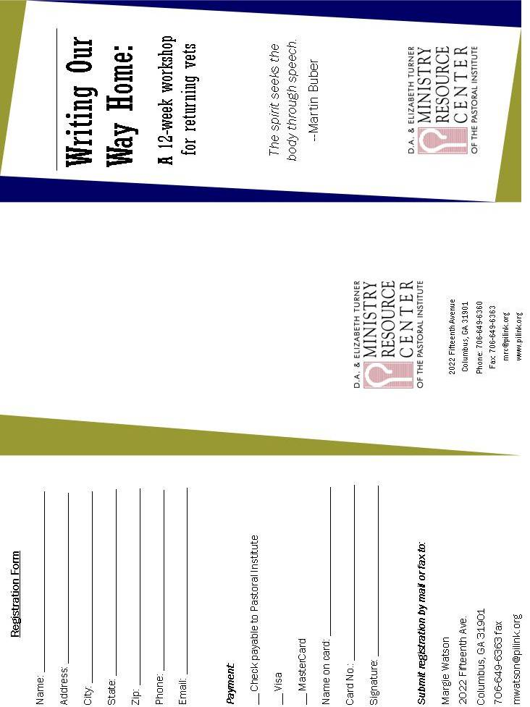
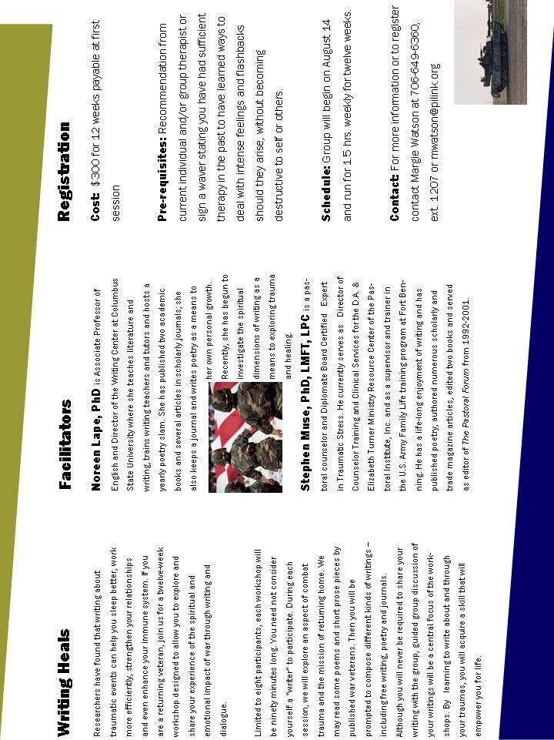

Part 2 – Other Congregation Programs

INTRODUCTION: This section of the toolkit lists other ideas that have merit. In general, they require more resources and organization time to plan and implement. They may also have a higher cost associated with them. Nonetheless, these programs are provided in the hope that they can serve as a catalyst to creating at least one military ministry in your church.

PROGRAM SUGGESTIONS:

- Sponsoring a gathering once a month for Active Duty, Guard, and Reserve military families of all services in your community to come together.
  - Time to “network” and get to know each other
  - Kid-friendly
  - Provide a meal, movie, speaker, or program
  - Emphasis on predictable meeting time to establish relationships
  - Foster and encourage these military families becoming a support for each other
- Providing childcare times where spouses of deployed might drop off children and have some free time to regroup and refresh or times when reuniting couples might enjoy an evening out
- Offering special children’s programs or playgroups or tutors for school subjects
- Advertise and host a Bible Study small group for military families
- Advertise and host courses on strengthening marriages for military families
- Deliver some meals to provide encouragement
- Offer to assist with chores in the yard or around the house
- Offer to sit with a wounded Service Member so the family care-giver can run errands or have a bit of time away. Respite care for these families is a BIG need.
- Be there to coordinate a temporary home for pets if a family must leave suddenly to go to the bedside of a wounded family member.
- Invite the chaplain of a nearby unit (Guard or Reserve) to come and speak to your congregation about ministering to service personnel and offer support to that unit.
- Partner with the local American Legion to conduct “Welcome Home” ceremonies.
- Host a special concert to raise awareness of Wounded Warrior issues. Take a special offering to support one of the organizations that work in support of this population. www.qolfoundation.org
- Searchable database will help to identify a worthy organization.
- Find out who your denomination’s military chaplains are and where they serve. Adopt one and see what support is needed.
- Celebrate birthdays of the family members of the deployed and include these families in other holiday celebrations during the year as special guests.
- Assign a congregation member to be a congregation liaison to spouses of deployed Service Members. This liaison could connect with the spouses regularly and communicate needs to the congregation.
- Adopt the Fisher House (like a Ronald McDonald House) at Navy Medical Center and work to supply items they might need. If you are not located close to an installation, contact the nearest Veteran’s Administration hospital or satellite clinic to establish a partnership or contact the local Red Cross or USO.
- Make use of congregation counseling resources:
- Equip counselors to work with those suffering from Post Traumatic Stress Disorder (PTSD).
- Make congregation counseling services readily available and affordable to family members of military personnel.
- If congregation counseling services are not available, consider the CareForTheTroops Therapist Database available on the CareForTheTroops web site. You can search it and attempt to arrange their availability to support your workshop.

Part 3 – Selected Web Site Resources for Ministry or Referrals

VALIDATED RESOURCES YOU CAN USE!

Review the enclosed resource list and select a resource in a ministry area that appeals to you. To aid in the selection process, resources are grouped in broad ministry headings. Within each heading, a brief description and verified contact information is provided for each listed resource listed. Additionally, each resource is annotated to indicate whether they are ministry opportunities or referral services for active duty members and/or veterans.

For example, you chose Military Families for your ministry area. Review of resources reveals a ministry opportunity to be involved with camps for military children. Under the same heading a referral that can provide counseling services for a military family should you encounter that need. It is as easy as selecting a ministry area and resource, use the provided contact information to get involved, and go to work

Highlighted resources in each section are opportunities for churches/parishioners to engage in hands-on ministry. The remaining resources are referral services you can point your soldiers and veterans in your community and church to.

EMPLOYMENT AND HOUSING ISSUES.

www.esgr.mil/ - ESGR, a Department of Defense agency, was established in 1972 to promote cooperation and understanding between Reserve Component Service members and their civilian employers and to assist in the resolution of conflicts arising from an employee's military commitment. Volunteers, hailing from small business and industry, government, education and prior military service bring a vast wealth of experience to assist in serving employers, service members and their families.

www.elitesdvobsd.com - The San Diego Chapter of the Elite SDVOB Network is part of a nationwide network of chapters all working to support SDVOB legislation, and to ensure economic opportunity for Service Disabled Veteran Owned Businesses. The entity is incorporated as a 501(c)19 organization. Our main focus is to help small service disabled veteran-owned businesses connect with corporate and government agencies.

www.vetsuccess.gov/home - The transition from military to civilian life can be both exciting and challenging. The goal of VetSuccess In Transition is to equip Veterans with the tools necessary to acquire that "perfect" job that matches their abilities and ambitions.

www.friendsofhomelessveterans.org/ - Friends of Homeless Veterans was established to make sure that San Diego's homeless veterans get help when they need it most. Founded informally in 2007 by Martin Brennan, the organization has grown in scope and formality and, with your help, we will continue to improve the quality of life for the homeless veterans in San Diego.

www.vvsd.net - VVSD is a nationally-recognized nonprofit and non-governmental organization that has served all veterans since 1981 and is dedicated to the promise to "Leave No One Behind.” With five locations throughout San Diego County, VVSD is the only program of its kind in the United States. Each year VVSD provides services to more than 2,000 military veterans, men and women, who have served and sacrificed for our country.

FAMILY/CHILDREN/MILITARY SPOUSES

www.operationhomefront.com/california/ - VISION: Through generous, widespread public support and a collaborative team of exceptional staff and volunteers, we aspire to become the provider of choice for emergency financial and other assistance to the families of our service members and wounded warriors. Where there is a need we do not provide, we will partner with others for the benefit of our military families.

www.saysandiego.org/programs/programdetails.asp?id=26 - Healthy Start Military Family Cluster (HSMFC) is a collaborative effort between the schools, US Navy, and public and private agencies to assist military families in Chesterton, The Villages at NTC, Serra Mesa, Gateway Village, and Murphy Canyon Military Family Housing. The mission of our Military Family Cluster is to provide confidential, safe, coordinated services that will lead to improved developmental, academic and social outcomes for children and a better quality of life for their families. Home visiting services including developmental assessments are available to military families living in the North Central region of San Diego, including the Marine Corps Air Station at Miramar. SAY San Diego serves as the fiscal and administrative agent for this collaborative effort. Contact Information: 858-496-0044

www.militarychildrenscollaborativegroup.com/ - To provide essential home front support for our military children and their care-giving families during training or deployment. We are composed of Governmental agencies, school administrations, teachers, Faith based organizations, Non profits, and child/family advocates.

www.Militaryhomefront.com – Welcome, Troops & Families. Military life comes with unique challenges. It is a world with a language of its own, a new way of doing things from shopping at the commissary to moving to foreign lands. Having trusted information on how to deal with these challenges can make the difference between stress and success. This is the place to come for the most accurate and up-to-date information about Department of Defense programs serving troops and their families.

www.militaryfamily.org/our-programs/operation-purple/ - -

When you hear "Operation Purple camp" you should think: Kids Serve Too! The National Military Family Association's Operation Purple camps are a time for having fun, making friends, and reminding military kids that they are the Nation's youngest heroes. The mission of the Operation Purple program is to empower military children and their families to develop and maintain healthy and connected relationships, in spite of the current military environment. The program is joint or "purple"— and open to children and families of active duty, National Guard or Reserve service members from the Army, Navy, Air Force, Marine Corps, Coast Guard, or the Commissioned Corps of the US Public Health Service and NOAA.

www.focusproject.org/ - Camp Pendleton 760-859-6079, 29 Palms 760 830-3818, Navbase SD 619 556-6076. As a service initiated by the Bureau of Medicine and Surgery (BUMED), FOCUS Project addresses concerns related to parental combat operational stress injuries and combat-related physical injuries by providing state-of-the-art family resiliency services to military children and families at designated Navy and Marine Corps sites.

PTSD/EMOTIONAL HEALTH/SUICIDE PREVENTION

National Suicide Prevention Hotline: 1-800-273-TALK (Veterans press 1)
www.militarymentalhealth.com/ - The Mental Health Self Assessment Program (MHSAP) is a mental and alcohol and referral program provided for military families service members affected by deployment and mobilization. Anonymous self-assessments are available for depression, bipolar disorder, alcohol use, PTSD, and generalized anxiety disorder. Assessments are offered online, by phone, and at four installations located in the San Diego area (see website for location and contact data).

www.vetcenter.va.gov/ - -
San Diego Center 619 294-2040, San Marcos Center 760 744-6914. Readjustment counseling is a wide range of psycho social services offered to eligible Veterans and their families in the effort to make a successful transition from military to civilian life. They include:

- Individual and group counseling for Veterans and their families
- Family counseling for military related issues
- Bereavement counseling for families who experience an active duty death
- Military sexual trauma counseling and referral
- Outreach and education including PDHRA, community events, etc.
- Substance abuse assessment and referral
- Employment assessment & referral
- VBA benefits explanation and referral
- Screening & referral for medical issues including TBI, depression, etc.

www.woundedwarriorproject.org/ - To foster the most successful, well-adjusted generation of wounded service members in our nation's history.

Objectives:
- To raise awareness and enlist the public's aid for the needs of injured service members.
- To help injured service members aid and assist each other.
- To provide unique, direct programs and services to meet the needs of injured service members.

WOUNDED SOLDIERS

www.sandiego.va.gov – The VA team focuses on veterans with challenges integrating into civilian life. PTSD, TBI, spinal cord injuries, amputations, severe burns and other serious health issues are treated at the San Diego VA hospital, and at five (5) clinics located in San Diego and Imperial Counties. The VA is actively seeking volunteer support from faith based organizations.

www.dav.org/ - The 1.2 million-member Disabled American Veterans (DAV) is a non-profit 501(c)(4) charity dedicated to building better lives for America’s disabled veterans and their families. The DAV’s Voluntary Services Program operates a comprehensive network of volunteers who provide veterans free rides to and from VA medical facilities and improve care and morale for sick and disabled veterans. The DAV advocacy and services in the San Diego area provided via chapters located in the communities of Chula Vista, Escondido, Oceanside, Imperial, Palm Desert, Palm Springs, and 29 Palms.

The Army Wounded Warrior Program (AW2) is the official U.S. Army program that assists and advocates for severely wounded, ill, and injured Soldiers, Veterans, and their Families, wherever they are located, regardless of military status. Soldiers who qualify for AW2 are assigned to the program as soon as possible after arriving at the Wounded Transition Unit (WTU). AW2 supports these Soldiers and their Families throughout their recovery and transition, even into Veteran status

www.legion.org/heroes - "Heroes to Hometowns" is a transition program for severely injured service members returning home from OEF/OIF. "Heroes to Hometowns" establishes a support network and coordinates resources for those service members. Last year The American Legion's Heroes to Hometowns Program assisted over 1,100 veterans.

www.amvets.org/programs/vav - Veterans Affairs Voluntary Service (VAVS)
Founded in 1946 to provide for veterans in VA healthcare facilities, the Department of Veterans Affairs Voluntary Service (VAVS) is the largest volunteer program in the Federal government, with more than 350 national and community organizations involved in support of their mission. Volunteers assist patients by augmenting staff in such settings as end-of-life care programs, foster care, community-based volunteer programs, hospital wards, nursing homes and veteran outreach centers. AMVETS serves as one of the 60 major veteran, civic and service organizations that comprise the VAVS National Advisory Committee.

VETERAN AND ACTIVE DUTY SOCIAL SUPPORT
www.uso.org/ - SD Airport Terminal 1 - 619 235-6503; Downtown SD 619 235-6503. The USO’s mission is to lift the spirits of America’s troops and their families. A nonprofit, congressionally chartered, private organization, the USO relies on the generosity of individuals, organizations and corporations to support its activities. The USO is not part of the U.S. government, but is recognized by the Department of Defense, Congress and President of the United States, who serves as Honorary Chairman of the USO.
www.militaryymca.org/ - The Armed Services YMCA San Diego provides comprehensive, ongoing services to military service members and their families through over 40 free programs within four departments: Family Outreach, Military Youth and Community Outreach, Active Duty Programs, and Wounded, Injured and Ill Programs at Naval Medical Center to make military life easier.
We need your help. Please volunteer or donate today to help make military life easier for our San Diego military families with free programs like the Armed Services YMCA's Operation Kid Comfort program or free confidential, in-home counseling for military families.
www.militaryonesource.com - Military OneSource is a free service provided by the Department of Defense (DoD) to active duty, Guard and Reserve service members, and their families with comprehensive information on every aspect of military life including deployment, reunion, relationships, grief, spouse employment and education, parenting and child care, and much more.

Military OneSource has policy and programmatic information, helpful resources, products, and articles and tips on numerous topics related to military life. Services are available 24 hours a day by telephone and online. In addition to the website, Military OneSource offers call center and online support for consultations on any number of issues such as spouse education and career opportunities, issues specific to families with a member with special needs, and financial support and resources.

www.militarymissionsnetwork.com - First and foremost, the Military Missions Network is a spontaneously emerging network. It is not an organization. It does not involve any hierarchical structure. It is beyond any church, ministry or grouping of such. There is no membership. This network is arising from a common philosophy shared by evangelical Christians involved in the domain of Military Missions. It is about spiritual movements and global Military Missions.

Evangelical churches, chaplains and ministries registered with the MMN share a common commitment to the Great Commission and a mutual love for those in the military. Relationships and partnerships between particular churches, chaplains and ministries linked through this network are based on voluntary associations, common convictions, mutual benefits, and shared goals. All such relationships and partnerships are initiated by individual parties.

www.CareForTheTroops.org/about_programs.php - Congregation-based Military Ministry Programs are a step toward supporting active military and veterans of the current and past conflicts. These programs are fundamental to the success of the CareForTheTroops effort as they represent the primary participation vehicle for Congregations to participate in the CFTT Initiative and also an important element in qualifying as a Veteran Friendly Congregation. It is a very key way for spreading the word and connecting with military family members in need on a local level.

Part 4 – Veteran Friendly Congregation (VFC) Designation - Implementation Guide

Congregational Leaders/Lay Leaders
Military Ministry congregation leaders are expected to be instrumental in obtaining a CareForTheTroops (CFTT) Veteran Friendly Congregation (VFC) designation for their congregation. The Veteran Friendly Congregation Program's purpose is twofold. First, it provides a visible sign, demonstrated through the congregation’s activities and communications, to members and visitors that the congregation is sympathetic to the needs of veterans and their families. Second, it acknowledges sincere and earnest efforts to support veterans and their families.

  - As part of the Program, Veteran Friendly Congregations annually renew their participation with CFTT based on the following criteria:
- Adopt one or more of the Military Ministry Programs suggested by CareForTheTroops, or approved and agreed to in discussions with the CareForTheTroops organization. Both CFTT VFC Board and Committee Members and Lead Congregations can provide this approval.
- Advertise the existence of the Military Ministry Program(s) in one or more of the congregation publications (service bulletins, newsletters, etc.) at least twice a month throughout the year, so that their existence is easily visible to visitors, members, and leadership of the congregation.
- Annually acknowledge compliance with the provisions above by sending a letter to the CFTT office address shown at www.careforthetroops.org/vfc.php , ATTN: Veteran Friendly Congregation Program by November 15th of each year to allow time to process the certification before the end of the year. Initial applications for consideration will be processed within 4 weeks of receipt.
- Grant permission to CFTT to list the congregation as either a VFC or a Lead Congregation on the CFTT website.
It is important to recognize that each congregation can act on their own. The way CFTT has set this up:
- no faith has to act in any way like another faith
- no congregation has to act like another congregation
- no congregation has to have a Ministry like any other congregation
- every Military Ministry is completely customizable to each congregation's desire to act
NOTE: An example of a renewal letter is included at the end of this section.
  - Congregational Leaders/Lay Leaders should obtain approval for this ministry through their congregation’s usual and customary methods.
List the key persons, committees, etc, with which to discuss this ministry, i.e, Congregation leader, lay leadership committee, administrative board, etc.
    - ____________________________________________________
    - ____________________________________________________
    - ____________________________________________________(Expand list as necessary)
C Form a Core Team
(List those that would be good candidates for the core team. Strongly consider a diverse group that would include: teachers/educators, business persons, retired, former or current military personnel, etc.)
1.______________________________________________
2.______________________________________________
3.______________________________________________
4.______________________________________________
D Decide which programs to implement
(A list of programs to consider can be found on the CFTT website www.careforthetroops.org/about_programs.php. You can also create other programs that your congregation thinks of or has in operation already. Be sure to coordinate with CFTT or the Lead Congregation to receive approval if you wish to implement a new CFTT program not currently listed in this document.
1.______________________________________________
2.______________________________________________
3.______________________________________________
4.______________________________________________
(Expand list as necessary)
E Submit the VFC letter to the CFTT or LC organization. The letter format is shown at the back of this guidebook.
Date VFC Letter sent to CFTT or Lead Congregation: ______________
- Develop a strategy to implement each program.
Program Leader Strategy Funding
1. _______________________________________________________
2. ______________________________________________________
3.________________________________________________________
4. _______________________________________________________
- Determine the approach to communicate and advertise the CFTT ministry throughout the congregation, e.g. Monthly newsletters, weekly service bulletins, emails, lawn signage, web sites, etc.
Program Leader Strategy Funding
1. ________________________________________________________
2. _______________________________________________________
3. _______________________________________________________
4. _______________________________________________________
- Consider the following communications about the recent decisions and the background behind the decisions. Examples of these letters are provided at the end of this section.
- Letter from the leadership to the congregation
- Letter to congregation members who have identified themselves as being directly or indirectly involved with someone serving in the military.
- An article in the congregation newsletter, website, and/or an email to the congregation
- Lead Congregations – Once a congregation chooses to begin a “Military Ministry”, they may also choose to become a Lead Congregation and, in doing so, begin to encourage other congregations in their own faith and/or in all faiths in their geographic proximity to implement these programs.
Lead Congregations are essential to CFTT's ability to expand this ministry throughout the state and share the information needed both by military families and referral sources. Lead Congregations are the LEADERS in their geographic area and become the organization responsible for raising awareness about this help.
The responsibilities of Lead Congregations are not fixed, but encompass the following types of activities:
- Act as an overall advocate and emissary of the CareForTheTroops initiative.
- Recruit congregations of all faiths on the merits of developing a military ministry either with the Program suggestions supplied by CFTT, or others of their own creation (and we would like to consider including those ideas as part of the CFTT list of suggested programs)
- Approve programs not in the CFTT Guidebook and issue letters of approval to the VFC congregations (copied to CFTT).
- Provide feedback to CFTT on how the programs are being used and any improvements that are needed to the documentation.
- Feedback on new ideas and programs discovered while speaking with other congregations that they have already implemented.
- Assist the Regional Trainers with scheduling presentations and events.
- Assist CFTT in the collection of the annual VFC renewal letters.
- Assist with fundraising if local foundations or private benefactors are involved. They would not be asked to participate in other parts of the state where other Lead Congregations exist.
- With the above guidelines in mind, consider implementing some of the following activities/initiatives:
  - Contact other community congregations. First, discuss the CFTT with the pastor, rector, lay leaders, and congregation administrators or boards. If needed, help to identify key groups within the congregation that seem to be the most active or influential. These are often women’s or men’s groups, Sunday school classes, certain denominational orders, etc. It is expected these will vary by faith denomination and by congregation within a denomination
(List the congregations within your community that would be good candidates for this ministry.)
Congregation Contact Phone email
1.______________________________________________________
2._____________________________________________________
3.______________________________________________________
4._____________________________________________________
(Expand list as necessary)
  - Contact other community organizations that interact with veterans. Consider the local National Guard units, VFW, men’s or women’s clubs, other faith-based organizations, etc.
(List these prospective community organizations.)
Congregation Contact Phone email
1.______________________________________________________
2._____________________________________________________
3.______________________________________________________
4._____________________________________________________
(Expand list as necessary)
  - Contact community organizations involved in job training, employment aid, health care, schools, and counseling groups and individual therapists. Consider sponsoring at least one annual event with local counselors interested in working with military- related issues and families and leaders of the local VFCs; encourage both the counselors to enroll in the CFTT database (http://careforthetroops.org/clinician_cftt_enroll.php), and the congregations to receive training from CFTT.
(List these organizations as possible contacts)
Organization Contact Phone email
1.______________________________________________________
2._____________________________________________________
3.______________________________________________________
4._____________________________________________________
(Expand list as necessary)
  - Advertise CFTT and the activities being done by the local congregations. Consider articles in the local newspaper(s), local radio, speakers for civic groups such as Lions Club, Rotary, etc.
(List media that could be used to advertise CFTT)
Organization Contact Phone email
1.______________________________________________________
2._____________________________________________________
3.______________________________________________________
4._____________________________________________________
(Expand list as necessary)
- Additional Notes The following are additional notes and comments regarding developing either the VFC Congregation or Lead Congregation activities:
- Seek help and guidance from the CFTT leadership and other Lead Congregations at any point in time. You are not in this alone. The CFTT organization and other Lead Congregations are available to assist with presentations, meetings, speaking engagements, etc.
- Funding is important. The Military Ministry Programs are fairly low budget programs, but funding is still critical to their success. Consider various fund raising events for your congregation and community.
- Utilize the resources available at www.careforthetroops.org. You will find form letters; templates and other guidelines that will help you develop your ministry. These resources are constantly evolving. Also, contact information for key people is available.
- Networking is important. Whenever possible make contact and discuss your activities with your peers in other congregations. Share experiences, both good and bad, and discuss future planned activities. (Over time, in the future), CFTT will organize regular round-table sessions with Lead Congregation leaders.

Veteran Friendly Congregation (VFC) Approval / Renewal Letter Example

DATE: _______________
CareForTheTroops, Inc.
ATTN: Veteran Friendly Congregation Program
1795 Johnson Ferry Road
Marietta, GA 30062
This letter is to certify that the Congregation: _____________________________________, located at address: __________________________________________________________,
makes to the following three commitments through the year ending 12/31/______.
- We agree to adopt or implement one or more Military Ministry Programs.
- We agree to advertise the existence of the Military Ministry Program(s) in one or more of our congregation publications (service bulletins, newsletters, etc) at least twice a month, all year long so that their existence is easily visible to visitors, members, and leadership of the congregation.
- We provide permission to the CareForTheTroops organization to list our congregation information on their web site.
We would also like to be a Lead Congregation and help establish Military Ministries in parishes and congregations in our vicinity. [if this does not apply, then erase or cross out this sentence]

Signed: _____________________________________________

Title: _____________________________________________

Clergy Contact Info:

name:____________________ email: ______________ phone no: _________

Lay Leader Contact Info

name:____________________ email: _______________ phone no: _________

To be Signed by the Rector, Pastor, Minister, Rabbi, Imam or designated Congregation Leader.
Letter from Congregation Leadership to Congregation, Example 1

TO: Members of the Congregation

FROM: [Congregation Leader Name]

SUBJECT: Military Ministry Programs

This congregation has decided to make intentional steps to support active military, their families, and veterans of the current and past conflicts as well as civilian contractors who have served in combat zones.

The programs we are implementing have the following goals:
- Raise and maintain an awareness of the needs of our military who are sacrificing their time and efforts to defend our country. [Help the congregation maintain an awareness of the existence and needs of those sacrificing their time and effort to support our country]
- Create a welcoming environment for any family members who worship with us or visit our congregation.
- (Accept (?)) Acknowledge the physical, material and spiritual needs of military members, veterans and their families.
- Extend an open hand to assist them in their challenges.

We plan to implement the following programs: [list them]. More information and updates regarding these programs can be found in our [list your congregation specific media, e.g newsletters, website, etc.]. Additional information on the overall program can be found on the CareForTheTroops website at http://www.careforthetroops.org/about_programs.php

The person(s) in our congregation responsible for the overall implementation of this ministry are shown below. We encourage you to contact them with any questions or new ideas for inclusion in our Ministry programs.
- [Name, phone, email]
- [Name, phone, email]

Signed

Military Ministry Leader and Congregation Leader

Letter from Congregation Leadership to Congregation, Example 2
Date
TO: Members of the __________________ [Name of Congregation]
FROM: [Name of Military Ministry Leader]
SUBJECT: Military Ministry Programs
The leadership of [name of congregation] has decided to make intentional steps toward supporting active military and veterans of the current and past conflicts. The set of support programs are intended to help support the entire extended family members associated with the person that is or has been in the military.
The programs outlined in this document have the following goals:
- Help the congregation maintain an awareness of the existence and needs of those sacrificing their time and effort to support our country
- Create an environment of acceptance for any extended family member who worship or visits our congregation.
- Accept the physical, material and spiritual needs of military members, veterans and their families.
- Provide an open hand to assist in their struggles.
More information and updates regarding these programs can be found on the CareForTheTroops web site, http://www.careforthetroops.org /about_programs.php
The Military Ministry at [name of congregation] seeks anyone who is willing to help to join with us. The person(s) in our congregation responsible for the overall implementation of this ministry are shown below. Feel free to contact them with any questions or new ideas for inclusion in our Ministry programs.
- [name, phone number, and email of military ministry leader(s)]
- …additional names as desired

Thank you for your attention to this announcement. Please feel free to make any request or provide any solutions.
Letter to a Congregation Member in the Military or Relative Example
Date
Dear [name of service member],
[NOTE: the service member may or may not be a member of the congregation; if they are not a member, they would be related to a person in the congregation]
My name is [name of Military Ministry leader] and I am writing this letter to express my fullest gratitude to you for the service you have rendered our community and our country by your service. I am grateful to God for allowing your safe return home.
I am also writing to extend an open and supportive hand to you and your family from the leadership and congregation of [name of congregation]. At [name of congregation] we are committed to assisting active duty, reserve, National Guard, retired service members, civilian contractors, and their families. Our Military Ministry has many resources to draw upon, both within our congregation and in connection with community organizations, and all for the long-term well-being of the service member.
Your service and the support of your family benefit us all and along with our faith motivate us to offer our service to you and your fellow servicemen and women. I would like to arrange a meeting with you and your family so we can become acquainted with you and identify how we may be of assistance to you. We recognize the military has many services and significant resources to take care of your immediate needs; however we stand ready to meet your long term, spiritual needs. We are a community congregation and are your neighbors in your time of need. We also wish to encourage you to make [name of congregation] your home congregation and join our community. We also wish to become better educated about your needs so that we may better serve men and women like you.
We hope you will consider this request and allow us to get to know you and serve you, as you have served us. Please consider us a caring resource, here to develop solutions to meet your needs. Where appropriate, we will act as a supportive conduit to professional help; otherwise, we are here to offer broad personal support teams in the community. Please let me know if you would be interested in our services. If you wish to simply correspond with me, please feel free to do so.
Sincerely,
[Name of Military Ministry Leader]
[contact info]
Article in Congregation Newsletter or Email to the Congregation Example
The following example was used at St Peter and St Paul Episcopal Church in Marietta, Georgia, and included in their monthly newsletter “Breaking Bread” that is distributed via email to the congregation with some printed copies made available at their church. This type of communication would be customized to fit the decisions made by the congregation’s Military Ministry team.
EXAMPLE:
Saint Peter and Saint Paul’s Military Ministry
The Military Ministry at Saint Peter and Saint Paul’s Episcopal Church has begun its work honoring those serving in the Armed Forces. As well, the Military Ministry recognizes the contributions made by the families of those in the military. This ministry seeks to express our clergy’s and congregation’s gratitude toward those serving in the ranks and going into harm’s way for the benefit of our country. And we wish to be ready to help those troops and their families within our community as they prepare themselves for civilian life.
[THE NEXT 2 PARAGRAPHS WOULD BE CUSTOMIZED TO YOUR SPECIFIC CONGREGATION]
St. Peter and St. Paul’s Military Ministry began with a presentation by Peter McCall to the Brotherhood of St. Andrews. Peter is a Vietnam veteran who heads an organization, CareForTheTroops.org. This organization envisions a program whereby community churches organize such ministries for helping troops and their families face the challenges of civilian life. Such challenges include the impact that trauma and Post Traumatic Stress Disorder (PTSD) upon returning warriors and their families. Just as importantly, the returning service member often needs the support of a spiritual home as they adjust to civilian life.
Encouraged by Father Robert and working with members of the Brotherhood of Saint Andrew, the Saint Peter and Saint Paul Military Ministry has been created with a dual purpose. Our ministry will focus both on outreach activities such as serving as a liaison for service members returning from combat, and on activities to honor the military and those within our church whose have served the military. With regard to outreach activities, we intend to be a source of direct assistance to service members and their families, providing them a spiritual home and support in their new lives. We will also establish contacts with such organizations as CareForTheTroops.org, Operation Homefront, CinCHouse.com, and the USO, so that we may direct service members and their families to these and other appropriate organizations for providing assistance for more intensive needs. We will seek to post information regarding our Ministry at local military installations, such as Dobbins Air Force Base, and work closely with the Newcomer’s Ministry to welcome those who visit our church. The St. Peter and St. Paul Military Ministry will seek ways to enhance the military’s identity within our church rites and activities, as a long-term source of comfort and honor for veterans and their families. The Military Ministry will be communicating with military members affiliated with our church and for whom we pray each Sunday. And we will generate ideas to properly commemorate the contributions of veterans to our church and community.
As an affiliate of CareForTheTroops.org, St. Peter and St. Paul will serve as a model for other Military Ministries. As such, the implementation and activities of our ministry will be documented for presentations to various churches in the immediate area and throughout the state.
[CUSTOMIZE THE NEXT PARAGRAPH TO YOUR SPECIFIC CONGREGATION]
Our core group consists of John Patton (USAF retired), Chuck Duncanson (US Army retired, with two children in the Armed Forces), Rudy Lind, Pete Williams and I. Our first organizational meeting took place earlier in March and we will continue meeting each two weeks. The Military Ministry will also sponsor coffee hours once a month to honor our veterans. Our organization seeks additional core members, especially those who have served in combat. Please contact me at rmills@smithcarter.com, or Pete Williams at peteIngridw@aol.com for further information.
Thank you for your support of this ministry.
[Signed by the Military Ministry Leader]
Part 5 - Veteran Friendly Congregations and Lead Congregation - Designation Programs

Veteran Friendly Congregation Designation Program

Introduction
The Veteran Friendly Congregation Program's purpose is twofold:
- to provide a visible sign to those visiting that this congregation has demonstrated that they are sympathetic to the needs of veterans and their families;
- to provide acknowledgement to the congregation and their leaders of their sincere and earnest efforts to support veterans and their families.

Program Requirements
The program requirements are simple and straightforward. Any congregation that meets the following criteria can qualify on an annual basis. Once qualified, a certificate will be sent to the Congregation Leader (or other person designated by the Congregation) which is suitable for framing and should be displayed in a prominent location such that it can be seen by visitors, members, and leaders of the congregation.

Annual Criteria
- Agree to adopt one or more of the Military Ministry Programs suggested by CareForTheTroops, or approved and agreed to in writing by the CareForTheTroops organization. CFTT Board Members and also Lead Congregations can provide this approval.
- Agree to advertise the existence of the Military Ministry Program(s) in one or more of your congregation publications (service bulletins, newsletters, etc) at least twice a month, all year long so that their existence is easily visible.
- Annually, renew the agreement with the provisions above by sending a letter to the CareForTheTroops office address shown at the bottom of this web page, ATTN: Veteran Friendly Congregation Program

- Renewal letters should be sent by November 15th to provide time to process them and send out certificates before the end of the year. If you sign up during the middle of the year, then the certificate will be issued within 4 weeks for the remainder of that year.

Veteran Friendly Congregation (VFC) Approval / Annual Renewal Letter Example

DATE: _______________
CareForTheTroops, Inc.
ATTN: Veteran Friendly Congregation Program
1795 Johnson Ferry Road
Marietta, GA 30062
This letter is to certify that the Congregation: ________________________________, located at address:___________________________________________________,
makes to the following three commitments through the year ending 12/31/______.
- We agree to adopt or implement one or more Military Ministry Programs.
- We agree to advertise the existence of the Military Ministry Program(s) in one or more of our congregation publications (service bulletins, newsletters, etc) at least twice a month, all year long so that their existence is easily visible to visitors, members, and leadership of the congregation.
- We provide permission to the CareForTheTroops organization to list our congregation information on their web site.
We would also like to be a Lead Congregation and help establish Military Ministries in parishes and congregations in our vicinity. [if this does not apply, then erase or cross out this sentence]

Signed: _____________________________________________

Title: _____________________________________________

Clergy Contact: Info:

name:____________________ email: ________________ phone no: _________

Lay Leader Contact: Info

name:____________________ email: ________________ phone no: _________

To be Signed by the Rector, Pastor, Minister, Rabbi, Imam or designated Congregation Leader

Lead Congregations

Introduction

Lead Congregations are essential to CFTT's ability to spread this ministry (and the information needed both by military families and referral sources). Lead Congregations are the LEADERS in their region/area and become the organization responsible for spreading the word about this help.

Once a congregation chooses to begin a “Military Ministry” within their congregation, they may also choose to become a Lead Congregation, and in doing so, begin to encourage other congregations in their region/area proximity of all faiths to implement these programs.

How this fits into the overall program is best described on the Program Overview page of this website.

The responsibilities of Lead Congregations are not fixed, but encompass the following types of activities:

- Be an overall advocate and emissary of the CareForTheTroops initiative
- Recruit congregations of all faiths on the merits of developing a military ministry either with the Program suggestions supplied by CFTT or others of their own creation (...and we would like to consider including those ideas as part of the CFTT list of suggested programs)
- Provide feedback to CFTT on how the programs are being used and suggest improvements that are needed to the documentation.
- Provide feedback on new ideas and programs discovered while speaking with other congregations that they have implemented.
- Provide assistance to the Regional Trainers with scheduling presentations and events.
- Assist with fundraising when local foundations or private benefactors are involved. Lead Congregations would not be asked to participate in other parts of the State where other Lead Congregations exist.

LC and VFC Responsibilities Comparison Table

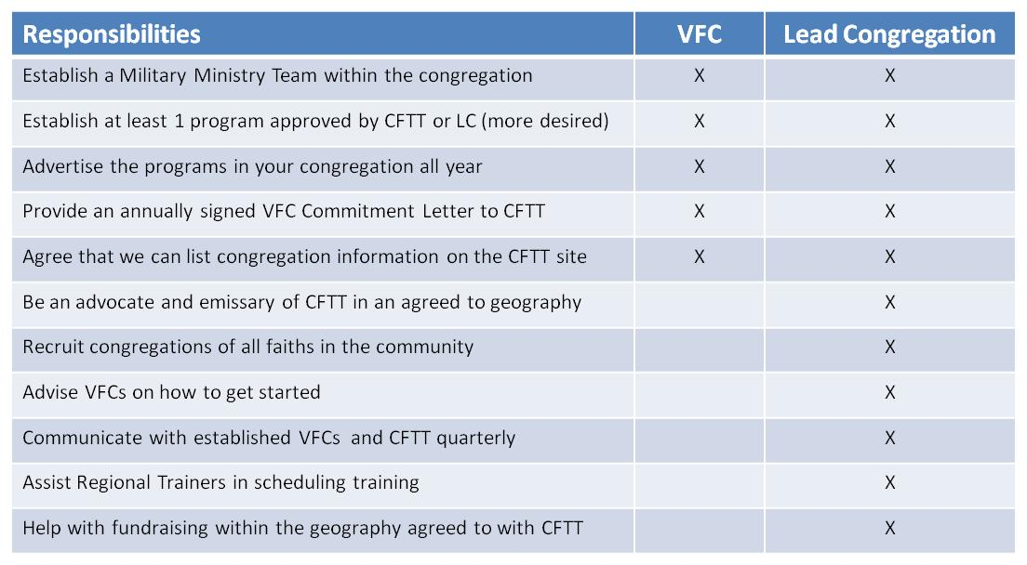

Almighty God, we commend to your gracious care and keeping
all the men and women of our armed forces at home and abroad.
Defend them day by day with your heavenly grace;
strengthen them in their trials and temptations;
give them courage to face the perils which beset them;
and grant them a sense of your abiding presence wherever they may be;
through Jesus Christ our Lord. Amen.

Book of Common Prayer, p. 823

