Appendix 5C Sample 3 - Newsletter Article

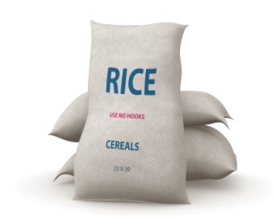
Title: A Rice Thing to Do
Text: Can you help us collect (XXX) pounds of white rice this month so we can help feed (XXX) people through (Organization Name)
For many years (?) the Sunday school children have been collecting peanut butter and jelly for (Organization Name) but they are also desperately in need of white rice and macaroni and cheese, so we have decided to spearhead monthly collections covering these four main staples.
We will start with white rice for the month of (Month) and ask that you bring your donations into church each week. If every family brings in a pound of rice we will easily reach our goal of (XXX) pounds! A table will be set up in front of the window on the Pomerado side of the church so we can watch our collection grow. The Sunday school children will be very excited to deliver their contributions each week when they enter church. Let’s see how much we can collect.

