Treasurer’s Report

For the year ending December 31, 2016, the diocese budgeted for operations $2,103,366 from all sources including Common Life Share, Donations, fees, investment payout/income and temporarily restricted assets. The budget was balanced. The projections as of September 30 indicate that the year will end with a positive budget variance of $79,900. 2016 projections are included in the budget tables shown on the next several pages.

Sources of funds are projected to be better than budget by $46,200. This is largely due to programs and ministry donations and fees larger than budget resulting from unanticipated youth events as well as donations for the North Park Project. (See description of North Park Project in Chief of Staff report). Other sources of funding are tracking closely to budget.

Operating expenses this year are projected to be lower than budget by $33,700. Episcopate expenses are over budget due to audit and professional services expenses. Congregational operating support is over budget due to unbudgeted expenditures for St. Anthony’s and St. Andrew’s in Lake Elsinore. Programs and ministry as well as Episcopal Church Center expenses are over budget but are offset by program and ministry fees and donations discussed above. The New Initiatives budget for 2016 was for Hispanic ministry. The actuals are lower than budget because a missioner has not yet been hired. However, the projected actuals for 2016 include the North Park Project which officially began on October 1, 2016. General contingency shows zero expenses; expenses authorized out of the general contingency as well as the mission contingency are shown in the individual line items that incurred the expense.

In September, the diocese sold the St. Anne’s property for $2.8 million dollars and netted $2,613,000. The Executive Council voted to use the proceeds to pay off the bank notes for St. Timothy’s and St. Thomas and enter into notes with them for their mortgage balances. The 2016 payments from the two churches will be used to pay for this mission shift work which was approved by Executive Council subsequent to last year’s convention. The budget of $179,000 includes funding for the chief of staff, congregational coach, property missioner plus administrative support. See the Chief of Staff report for more information.

The last year to be audited was 2015. As part of the audit process, the diocese booked a loss on impairment of investment associated with property of $2.8 million dollars and an allowance for doubtful receivable of $630,000. These extraordinary expenses were taken to align the value of the St. Thomas property and loans with the broker opinion of value on the property. The 2015 audited financial statement shows $19million of assets, $3 million of liabilities and $16 million in net assets. The audited link to our audited 2015 financial statements can be found at http://edsd.org/who-we-are/about-the-diocese/diocesan-governance/.

Respectfully submitted,

Julie H. Young
Treasurer and Canon for Finance and Administration
2017 Budget Summary
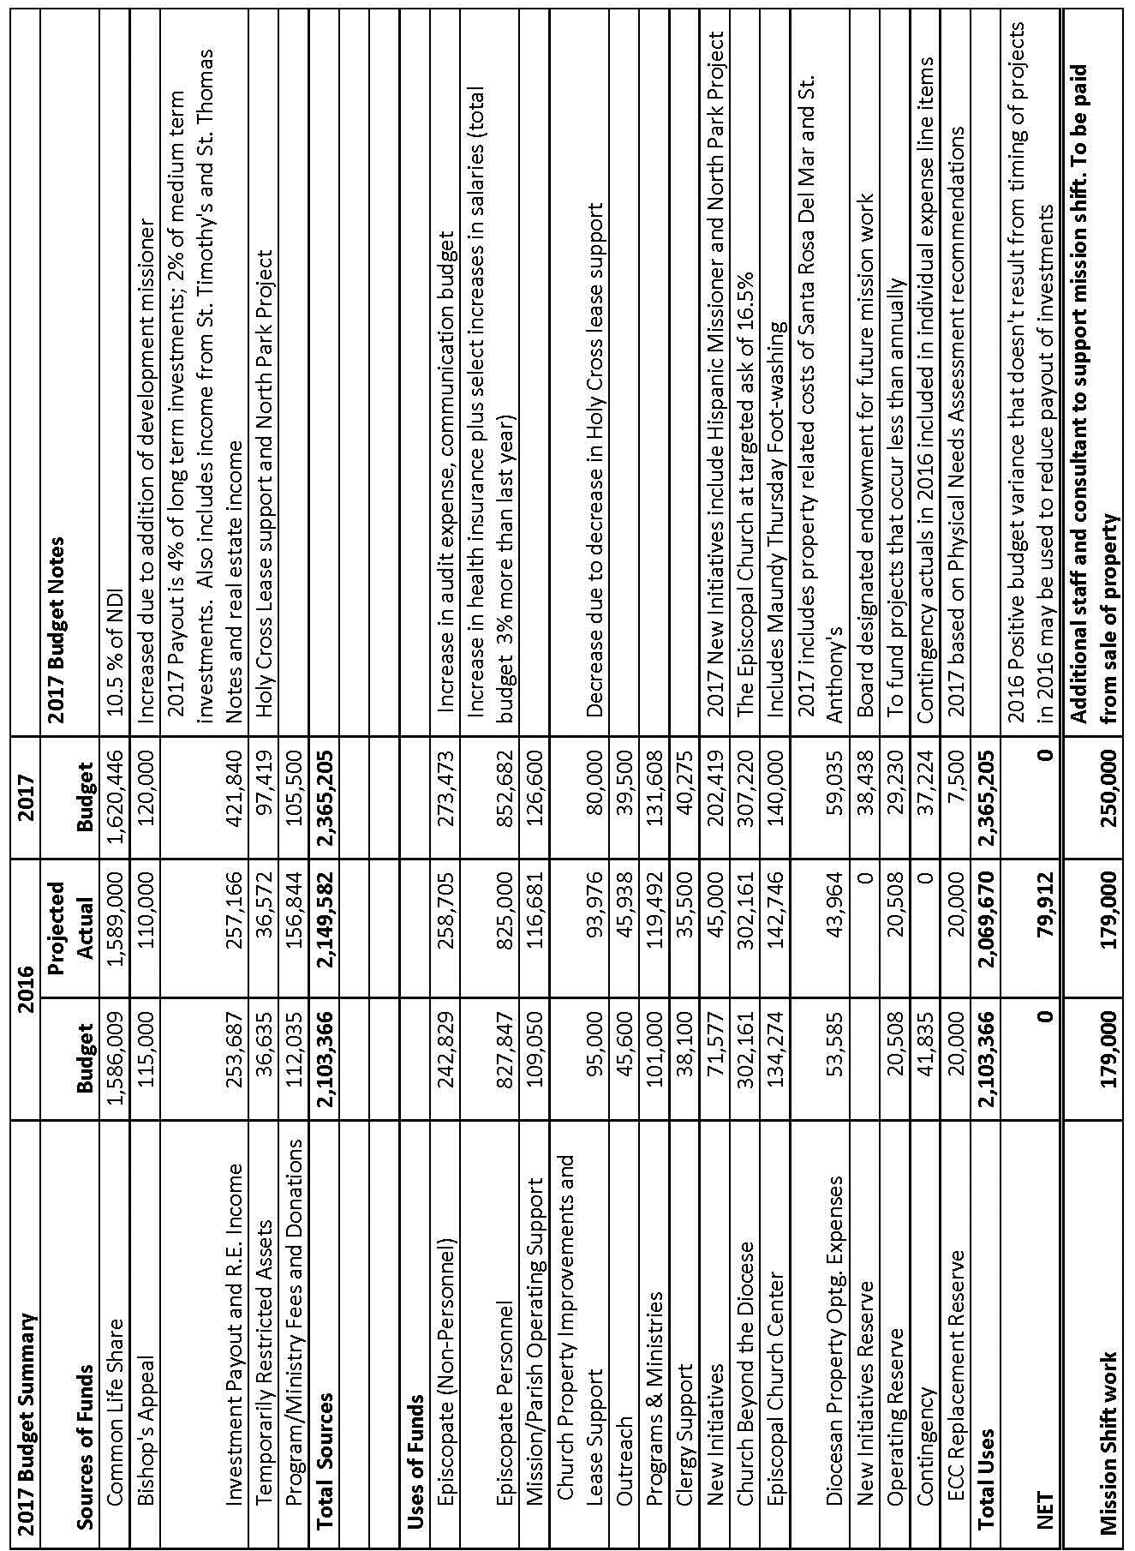

2017 Budget

The 2017 operating budget is balanced at $2,365,205.

Sources of funds include the following:
- Common Life Share: At convention last year, a resolution was passed to change the name of mission share pledge to common life share. The formula was also changed. The minimum common life share was increased from 10% to 10.5% of Net Disposable Income (Line B of the Parochial Report.) The target of 20% was eliminated. In its stead, an incremental common life share is requested for specific projects. The budget is based on 10.5%. Any incremental funding received will be used for projects outside of this operating budget. Common Life Share represents 69% of all funding.
- Bishop’s Appeal is projected at 5% of the funding. There is an increase of $5,000 from last year’s budget because the diocese is expected to hire a part time development missioner.
- Investment payout and real estate income: The diocese is reducing its payout from its long term investments from 5% to 4% and for its medium term investments from 2.5% to 2 %. While this reduces funding, this line item has increased because the diocese paid off the bank notes for St. Thomas and St. Timothy’s and entered into agreements with them to pay the diocese directly. The proceeds from these notes will be used to fund new initiatives and new initiatives reserves (see below).
- Temporarily restricted assets are funds that have been donated or designated for a specific use in prior years but are available in the current year. In 2017, funds are available to support the lease of Holy Cross as well as the North Park Project. (see New Initiatives description in the “Use of Funds” section below. In addition, 20% of the proceeds will be saved in a board designated endowment fund to provide support for future mission work.
- Program and Ministry Fees and Donations is comprised of money collected for specific events or programs. Included here are monies designated for School for Ministry, convention, clergy conference, youth events, and leadership academy.

Uses of funds include the following:
- Episcopate expenses are personnel and non-personnel costs related to the office of the bishop. Together they comprise 48% of the budget. The office of the bishop provides pastoral, administrative, and programmatic oversight throughout the diocese including bishop visitations.
- The Congregational Operating and Property Support line items are for direct funding for churches. In 2017, 5 churches and one region are budgeted to receive operating support. Because of uncertainty of projected need, a mission contingency budget of $58,000 is included from which Executive Council or the Finance Committee will authorize expenditures. The total amount budgeted in congregational operating support is $126,000 which is an increase over 2016. Congregational Property Improvements and Lease Support: Holy Cross will receive lease support per a prior year resolution of Executive Council. 2018 will be the last year of this support. Property improvement grants are available to congregations who have completed a physical needs analysis. Although only $8,000 is recommended for a specific grant from the 2017 budget, an additional $57,000 will be available for grants primarily for health and safety needs identified.
- Programs, ministries and outreach: A number of programs and ministries will be funded in 2017. The overall expenses for programs and ministries is 30% higher than the 2016 budget. Noteworthy is the increase in funding for youth ministry and fearless love grants. An expanded congregational development budget will provide resources to our churches including stewardship support, campus ministry, schools resourcing, planned giving, Leadership Academy, self-assessment and leadership development tools. . Young adult ministry has been folded into the North Park Project (see new initiatives below). Episcopal Refugee Network and Episcopal Community Services will continue to receive outreach grants from the diocese. In addition, Camp Stevens will receive a grant for camperships.
- Clergy support includes funding for retired clergy ministry, clergy conference, clergy wellness days, sabbatical and seminarian support. New this year is a small budget to support the work of the diaconate.
- The New Initiatives budget includes two new program areas. First, the diocese has plans to hire a full time Hispanic/Latino(a)missioner in 2017. 2016 had partial year funding for the position but as of the date of this report, it has not been filled. The second new initiative, the North Park Project (NPP) will blend diocesan efforts to reach unchurched people, minister to refugees, connect with millennials, and grow the church. The purpose of the project is trifold: 1) to boost the congregation at St. Luke’s; 2) to try new ministry, community outreach and missional living; and 3) to provide a model for the whole diocese through experimental, twenty-first century ministry. In addition to the two projects, $38,438 will be put into reserves to create a board designated New Initiatives endowment. This will allow us to continue the work of the missional church in the future.
- Church Beyond the Diocese includes support to the province and The Episcopal Church. The 2017 budget is at the targeted ask for each.
- The Episcopal Church Center (ECC) budget includes funding for operations outreach of the church center. This budget includes the cost of the compensation for the facilities manager and sexton as well as utilities, maintenance and supplies.
- Diocesan property costs are those associated with operating costs of various properties owned by the diocese. The budget next year shows a slight increase due to the diocese paying the building related costs of Santa Rosa del Mar and St. Anthony’s properties until they are sold.
- Operating and replacement reserve funding is budgeted to support programs and ECC capital improvements that happen less than once a year.
- Lastly, a contingency equal to 1.5% of the budget is available for unanticipated expenses or revenue shortfalls.

Mission Shift Work

Separate from the operating budget, the budget request includes funding of $250,000 for mission shift work. At last year’s convention, the bishop discussed the need for the diocese to shift to a less property centric, more missional focus. To accomplish this work, the bishop stated that he would ask for funding over the three-year period 2016-2018 from reserves to provide additional staffing. The Executive Council approved a budget of $179,000 for 2016 which will be funded from some of the proceeds of the sale of St. Anne’s. The budget for 2017 is $250,000 and includes funding for the chief of staff, congregational coach, property missioner, administrative support as well as an organizational development consultant. See the chief of staff’s report for detail on the shift work for 2016.

The Proposed 2017 Budget follows.

