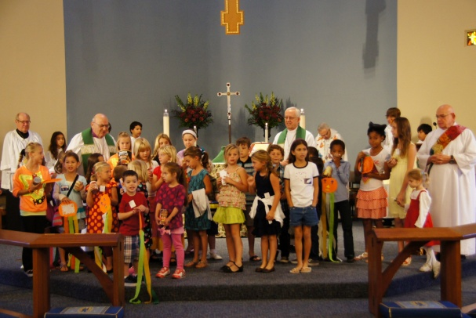

How to Feed the Hungry
The Church Challenge Tool Kit

By Pippa Mills, Sunday school director
St. Bartholomew’s Episcopal Church, Poway, CA 92064
www.stbartschurch.org
858-487-2159
The Rev Frederick W. Thayer, rector

Introduction and Purpose
In July 2012, St. Bartholomew’s launched a program to feed the hungry. We called it “The Church Challenge Outreach Program.” The Outreach program had has been a tremendous success feeding thousands of people.
The purpose of this Tool Kit is to provide congregations with the approach, the tools, the expectations and templates needed to create a similar program through the leadership of the Sunday school on your church.
This outreach program is also a great Evangelism tool because it provides a way to spread the good news of Jesus Christ into the community and make your congregation better known and more relevant.
Every aspect of this program has been tested. We know it works! It also binds a congregation together in purpose, helps children learn about stewardship and can make a difference in your community.
What Kind of Results Can I Expect?
After a 4 month test we collected over 1,500 pounds of Rice, 450 jars of peanut butter and jelly (PEANUT BUTTER AND JELLY), 1,200 boxes of Mac ‘n’ Cheese. We also collected 650 cans of beans! A good rule of thumb is to take the Average Sunday Attendance (ASA), (which you can get from your rector, vicar or priest in charge) then assume a minimum of one item per person. This would be a very conservative estimate.

Here’s What You Need to Know to Get Started
First - Get support: A large project like this is almost impossible to run yourself. Besides, you don’t want to. You want the congregation committed to the project. Call a Kick Off meeting with your clergy, office staff and most important, your Sunday School Director and Teachers to discuss your plan. Take a copy of this document with you.
Establish Ownership: The most important thing to do is for someone to take ownership of the program. In our case, it was the Sunday School Director who oversaw all collections and made sure everyone was kept up to date with how things were going. Weekly progress reports were provided to the Clergy, Office Staff and the congregation. The weekly results were included in our Sunday Worship Newsletter and announced from the pulpit. The appendices to this toolkit include templates you can use for this purpose.
Involve the children: Everyone loves children, so by having the Sunday school kids walk into church carrying their donations the rest of the congregation was encouraged to participate and show support for the project.
At St. Bart’s the Children come into the Sanctuary after the peace. Where they come in is not important. What is important is that the children carry their gifts into the church during the principle service.
It’s critical to assure that each child has at least one can or package to carry because it assures the congregation that the Sunday school is leading the campaign. On slow weeks, where the goal is not reached, it may be necessary to use your own personal donations along with those delivered to the Church office. You might want to hold a donation or two back on good weeks so children have something carry on slow weeks.
Second – Make a plan: You will need to decide if this is a one off event or an ongoing challenge that you will repeat on a regular basis.
How long should the collection last?
We recommend a single calendar month for each item. Consider running the challenge in a four (4) month cycle. With a gap of at least two months between events so the congregation doesn’t burn out from event malaise.
Think about a good time to start your challenge. We avoided November and December as we already have outreach opportunities for our congregation to support.
As a guide here are two sample plans...
- Run the food challenge in a four month cycle July, August, September, October.
- Or, January, February, March, April.
You may want to change the cycle to fit your congregation’s other events.
Ask, who do you want to help?
Does your Church already have ties with a food pantry or shelter? If so use it! We chose Interfaith Community Services (ICS) in Escondido because they had a significant need to fill their shelves with peanut butter and jelly; also because St. Bart’s was a founding congregation of ICS. Our program also supports the Episcopal Refugee Network (ERN) and the Episcopal Church Center (ECC) in Ocean Beach. Remember,you can help more than one organization each month or alternate recipients.
Key Point: Choose an organization that resonates with your congregation.
Now comes the challenge of deciding what to collect?
Key Point: It’s important to speak with everyone who will receive your donation before you begin the program. Some organizations are selective about what they need. The needs vary from organization to organization. For example, the Episcopal Refugee network needs mostly rice.
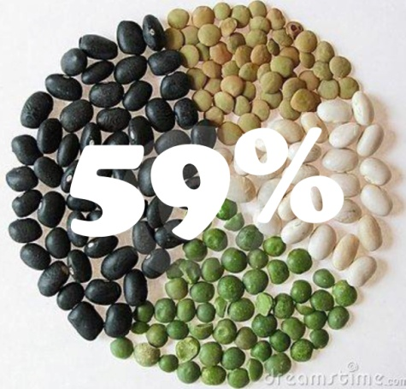
And The Episcopal Church Center (ECC) has a published annual collection list which was helpful in deciding what to collect. See Appendix 1. If you decide to support ECC contact Nancy Holland, the Executive Director, she will help you fit you program into the ministry needs of the ECC.
Third - Set a Goal & Calculate What is Achievable: Base your calculations on each person in the congregation donating one item. It is far better to underestimate than create an unachievable goal. If you achieve the goal in a few weeks just keep moving the goal posts.
Define Your Goals and Measure Progress
Let everyone know how you’re doing on a weekly basis through e-news publications, e-mails and notice boards. Use eye catching graphics to highlight how you are doing. The percent of target achieved works well along with how many more cans/boxes/jars you need.
Remind everyone that if they all bring in just one bag/box/jar the target can be reached.
In some cases you may have members who want to contribute, but can’t get out to buy an item. However, they may want to contribute funds for purchase. In these cases we suggest buying the items for them.

Fourth – Publicize! Make sure EVERYONE knows what you are doing: Come up with an easy to remember slogan related to the collection along with a saying that will be used throughout all collections. We used; ‘Together we can make a difference’ and then came up with sub themes for each month. ‘A Rice thing to do,’ ‘Spreading the News,’ ‘Say Cheese for Mac n Cheese’ and ‘Full of Beans’.
Make flyers and eye catching posters to be displayed around campus – See Appendix’s 2A, B, C and D for sample flyers.
You can also have large posters printed at Costco which should be placed at the entrance to the church. On average, they cost approximately $6 for a 16 x20 inch poster. The file can be created in Power Point, just remember to save it as a JPEG image.
Have the Sunday school children make small posters of the items being collected. Later they can be combined into one large poster and used for flyers. It’s a great opportunity to teach about stewardship. We made posters using dried beans, mac n cheese, or rice kernel’s glued to the poster announcing the theme of the month.
Key Point: Have the Sunday school children promote the program. Have them take some flyers home and give then to neighbors and friends. We had several newcomers bring their children to Sunday school because they wanted to be part of a congregation that was doing something for the community.
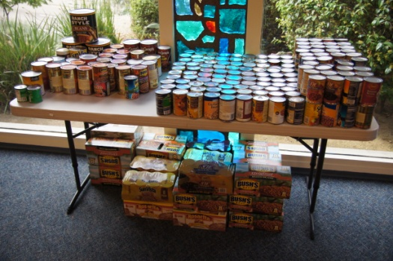
Keep the collection in Church.
It’s essential that everyone be reminded about the collection. Having your offering grow in the sanctuary is the perfect way to do this. We set up a table to the side of the Altar and hung a large poster above it explaining what the collection was for and where it was going. Appendix 3A and B includes samples of these posters for Peanut butter and jelly and Canned Beans.
Stacking items in piles of ten works well, along with stacking same sized items together, which makes counting the gifts much easier.
Beans Before Delivery

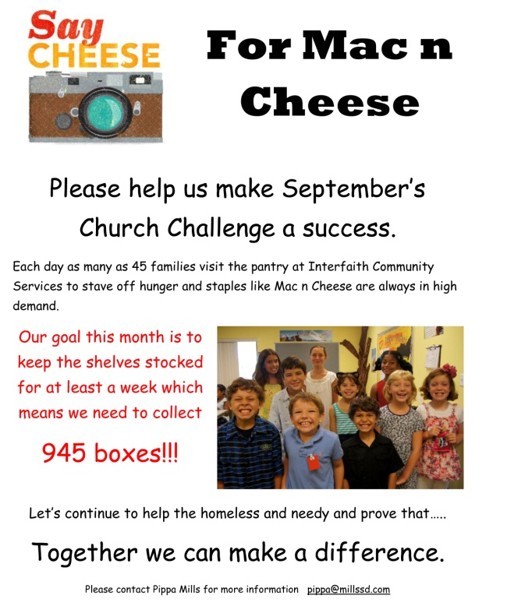
Include an update of progress in the bulletin announcements. Hearing how well you’re doing and how far you have to go at each service helps to put weight behind your collection. Include the status in weekly newsletters and bulletins.

Use a prominent notice board to publicize your collection and also record your progress. For our canned bean collection we used a dried bean to represent each can that was donated. When children bought in their donations into church they loved placing the bean in a box to represent their donation. We also colored in graphics of jars of PEANUT BUTTER AND JELLY and a bag of rice. Do anything you can to get the message out about how you are doing. The goal is to keep everyone involved and motivated. For those not aware of our challenge, we made sure a short blurb was included in the middle of the status board saying who we were helping and how much we wanted to collect. This approach told everyone what we were doing and encouraged folks to donate to the program. See appendix 4A, B, C and D for samples of Spreading the News posters and templates.
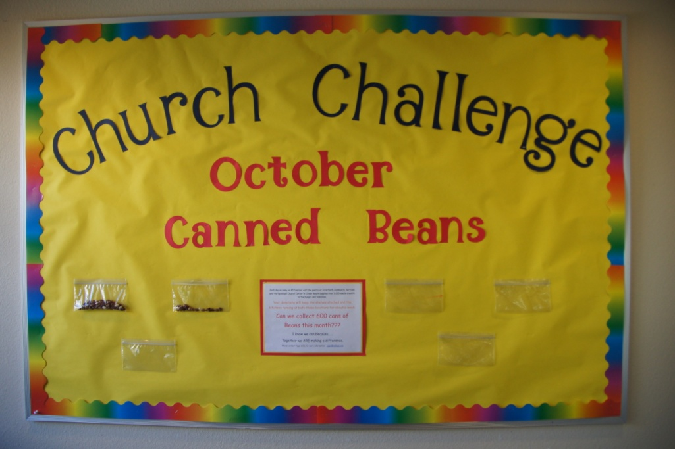

Keep Weekly and Monthly Updates Coming: Each week we wrote an article for our e-news communication. The point was to keep people informed. Using fun graphics and percentages made it easy to see how much we collected.
Key Point: If you are starting to fall, behind contact ministries within the church. Ask them to contact their members to remind them to bring in their donations. For us, this worked particularly well with the Worship Ministries and Sunday school families.
We also wrote an article for our monthly newsletter which provided an overview of how we were doing and also announced our next challenge to ensure donations kept coming even during the first week of the month. See Appendix 5A, B and C for sample newsletter templates.
Keep the Thanks Coming
Key Point: Constantly say, “Thank You!” The Sunday school leadership was truly touched by the generosity of our congregation. Key Point: Make sure you tell everyone possible about the challenge. To make the program successful networking by word of mouth will make a big difference. Publish thanks in e-news, monthly newsletters and don’t forget to say thank you when you see someone delivering an item. Make sure everyone knows that they can drop off items in the church office that can then be moved to the sanctuary before the next Saturday or Sunday services.
Fifth – Celebrate, Celebrate, And Celebrate:
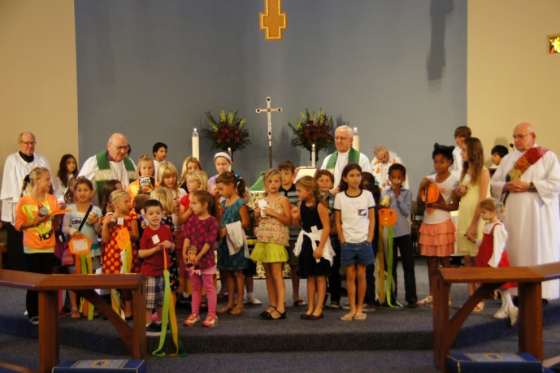
Have an end of collection Blessing During the Great Thanksgiving: At the end of each month the Sunday school children would enter church with their weekly collection. Instead of placing their gift on the collection table they would make their way to the altar and add their gift to the collection which had been moved into the chancel. During the peace, the food, the children and the congregation were blessed for the good work they had done.
This provides a great feel good moment and brings the whole congregation together to celebrate the success.

Sixth – Invite a Representative and Deliver in a Timely Manner
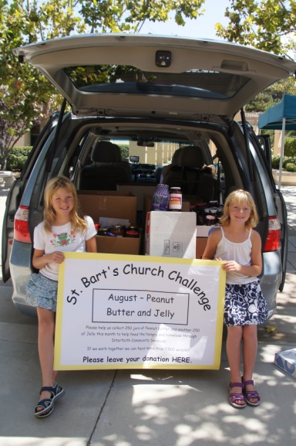
It is essential that the items be delivered within one week after completing the collection. An e-news or weekly newsletter item should be published so everyone knows the final collection results and how many people would be fed with the offering.
Key Point: Invite someone from the receiving organization to attend the final week and stand with the Sunday school staff, clergy and children in the chancel when the food and congregation are blessed. We have found it helpful for that representative to be offered an opportunity to thank the congregation personally.
If you can do it, the representative may cart the collections away after the service. The children love helping to load the delivery vehicle. This approach makes a special delivery unnecessary.
Take pictures of the delivery as food is stacked into the vehicle. Or shoot the empty shelves that you might find at the pantry before the food was delivered. Don’t forget the after shot. These are all great visuals for people and remind them that their help is being appreciated and is truly needed.
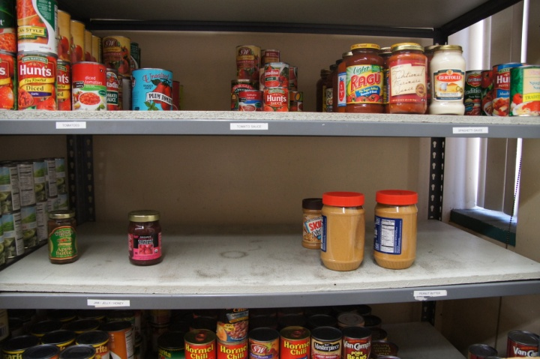
Empty Shelves at Interfaith Community Services

Seventh – Share your Success with the Community
Send articles with pictures to your local newspaper and magazines. This helps to publicize your church and the great work you are doing. See appendix 6 for a sample press release.
In Conclusion
We hope you will find this tool kit inspiring and useful. Every congregation is different so please adapt the kit as needed to suit your own situation. We can, as Jesus did, with hope and out of love, feed as many people who need to be fed and make a difference in our community and people’s lives. If you have any comments, suggestions or inspiring stories we would love to hear from you.
Many Blessings,
Pippa Mills, Sunday school director, St. Bartholomew’s Episcopal Church www.stbartschurch.org
pippa@millssd.com

Matthew 14:15-21
As evening approached, the disciples came to him and said, “This is a remote place, and it’s already getting late. Send the crowds away, so they can go to the villages and buy themselves some food.” Jesus replied, “They do not need to go away. You give them something to eat.” “We have here only five loaves of bread and two fish,” they answered. “Bring them here to me,” he said. And he directed the people to sit down on the grass. Taking the five loaves and the two fish and looking up to heaven, he gave thanks and broke the loaves. Then he gave them to the disciples, and the disciples gave them to the people. They all ate and were satisfied, and the disciples picked up twelve basketfuls of broken pieces that were left over. The number of those who ate was about five thousand men, besides women and children.
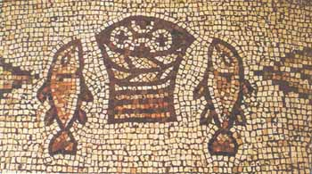

Scale your results. St Bartholomew’s Average Sunday Attendance is approximately 375 and Our Sunday School serves between 45-60 children
nholland@edsd.org, 1-619-823-8998
http://www.costcophotocenter.com/account/default.aspx?ReturnUrl=%2fDefault.aspx

