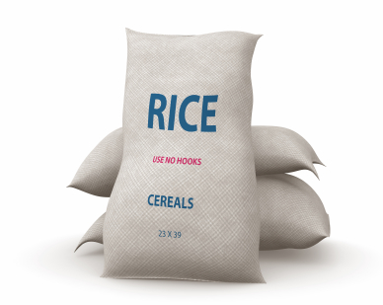

For many years the Sunday school children have been collecting peanut butter and jelly for (Insert Name) but they are also desperately in need of white rice and macaroni and cheese so we have decided to spearhead a churchwide monthly collection covering these four main staples.
July will be White Rice Month and we’d like to try and collect (XXX) pounds of rice which will feed (XXX) people through (Organization) and the (Organization). I know this sounds like a lot of rice but if we all bring in just one pound we can easily reach our goal.
Sunday school donations will be delivered to church when we enter and all other donations can be left on the table by the window on the Pomerado Road side of the church.
I can’t wait to watch our collection grow and look forward to helping those far less fortunate than ourselves.
It’s a rice thing to do.
For more information please contact (Your Sunday School Directors Name and Contact Info)

