Appendix 2C Sample Flyer

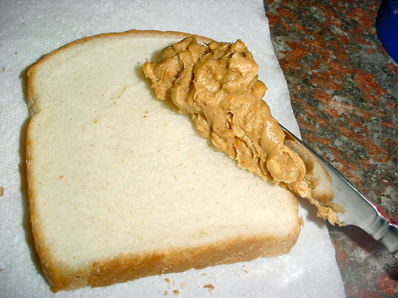

We’re
‘Spreading’
the news that
(Church) loves to
help others.

Please help us feed (XXX) people this month by donating jars of peanut butter and jelly throughout August. Our goal is (XXX) jars of each and after the amazing success of last month’s challenge I know we can do it.
Please bring your jars into Church or the Office or to Sunday school.
Together we can make a difference.
For more information please contact (Your Contact Information)

